<http://madscientistroom.org/chm/Sargon.html>

[](http://web.archive.org/web/)

[About this capture](http://web.archive.org/web/20021012231845/madscientistroom.org/chm/Sargon.html#expand)

[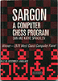](http://web.archive.org/web/20021012231845/madscientistroom.org/chm/Sargon-000-0cover.jpg)



# SARGON

## A COMPUTER CHESS PROGRAM

### DAN AND KATHE SPRACKLEN

[[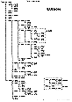](http://web.archive.org/web/20021012231845/madscientistroom.org/chm/Sargon-000-2-block.gif)Block diagram](http://web.archive.org/web/20021012231845/madscientistroom.org/chm/Sargon-000-2-block.gif)

HAYDEM BOOK COMPANY, INC.

Rochelle Park, New Jersey

ISBN 0-8104-51554

Library of Congress Catalog Card Number 78-64981

Copyright © 1978 by HAVDEN BOOK COMPANY, INC. All rights reserved.

No part of this book may be reprinted, or reproduced, or utilized in any

form or by any electronic, mechanical, or other means, now known or

hereafter invented, including photocopying and recording, or in any infor-

mation storage and retrieval system, without permission in writing from

the Publisher.

Printed in the United States of America

4 5 6 7 8 9 PRINTING

--------------------------------------------

79 80 81 82 83 84 85 86 YEAR

### CONTENTS

|  |  |
| --- | --- |
| Meet Sargon | [1](http://web.archive.org/web/20021012231845/madscientistroom.org/chm/Sargon.html#P1) |
| The Chessboard in Computer Graphics | [3](http://web.archive.org/web/20021012231845/madscientistroom.org/chm/Sargon.html#P3) |
| Chess Piece Summary | [6](http://web.archive.org/web/20021012231845/madscientistroom.org/chm/Sargon.html#P6) |
| Users Guide to Sargon | [11](http://web.archive.org/web/20021012231845/madscientistroom.org/chm/Sargon.html#P11) |
| Notes on the Implementation of Sargon | [17](http://web.archive.org/web/20021012231845/madscientistroom.org/chm/Sargon.html#P17) |
| Equates | [19](http://web.archive.org/web/20021012231845/madscientistroom.org/chm/Sargon.html#P19) |
| Direction Tables | [20](http://web.archive.org/web/20021012231845/madscientistroom.org/chm/Sargon.html#P20) |
| Point Value Array | [20](http://web.archive.org/web/20021012231845/madscientistroom.org/chm/Sargon.html#P20) |
| Board Array | [21](http://web.archive.org/web/20021012231845/madscientistroom.org/chm/Sargon.html#P21) |
| Attack List | [22](http://web.archive.org/web/20021012231845/madscientistroom.org/chm/Sargon.html#P22) |
| Pinned Piece Array | [22](http://web.archive.org/web/20021012231845/madscientistroom.org/chm/Sargon.html#P22) |
| Score and Ply Tables | [23](http://web.archive.org/web/20021012231845/madscientistroom.org/chm/Sargon.html#P23) |
| Table Indices Section | [24](http://web.archive.org/web/20021012231845/madscientistroom.org/chm/Sargon.html#P24) |
| Variables Section | [25](http://web.archive.org/web/20021012231845/madscientistroom.org/chm/Sargon.html#P25) |
| Move List Section | [27](http://web.archive.org/web/20021012231845/madscientistroom.org/chm/Sargon.html#P27) |
| Board Setup Routine | [28](http://web.archive.org/web/20021012231845/madscientistroom.org/chm/Sargon.html#P28) |
| Path Routine | [29](http://web.archive.org/web/20021012231845/madscientistroom.org/chm/Sargon.html#P29) |
| Piece Mover Routine | [30](http://web.archive.org/web/20021012231845/madscientistroom.org/chm/Sargon.html#P30) |
| En Passant Routine | [32](http://web.archive.org/web/20021012231845/madscientistroom.org/chm/Sargon.html#P32) |
| Adjust Move List Pointer | [33](http://web.archive.org/web/20021012231845/madscientistroom.org/chm/Sargon.html#P33) |
| Castle Routine | [34](http://web.archive.org/web/20021012231845/madscientistroom.org/chm/Sargon.html#P34) |
| Admove Routine | [36](http://web.archive.org/web/20021012231845/madscientistroom.org/chm/Sargon.html#P36) |
| Generate Move Routine | [37](http://web.archive.org/web/20021012231845/madscientistroom.org/chm/Sargon.html#P37) |
| Check Routine | [38](http://web.archive.org/web/20021012231845/madscientistroom.org/chm/Sargon.html#P38) |
| Attack Routine | [39](http://web.archive.org/web/20021012231845/madscientistroom.org/chm/Sargon.html#P39) |
| Attack Save Routine | [42](http://web.archive.org/web/20021012231845/madscientistroom.org/chm/Sargon.html#P42) |
| Pin Check Routine | [43](http://web.archive.org/web/20021012231845/madscientistroom.org/chm/Sargon.html#P43) |
| Pin Find Routine | [44](http://web.archive.org/web/20021012231845/madscientistroom.org/chm/Sargon.html#P44) |
| Exchange Routine | [47](http://web.archive.org/web/20021012231845/madscientistroom.org/chm/Sargon.html#P47) |
| Next Attacker/Defender Routine | [48](http://web.archive.org/web/20021012231845/madscientistroom.org/chm/Sargon.html#P48) |
| Point Evaluation Routine | [49](http://web.archive.org/web/20021012231845/madscientistroom.org/chm/Sargon.html#P49) |
| Limit Routine | [51](http://web.archive.org/web/20021012231845/madscientistroom.org/chm/Sargon.html#P51) |
| Move Routine | [54](http://web.archive.org/web/20021012231845/madscientistroom.org/chm/Sargon.html#P54) |
| Un-Move Routine | [56](http://web.archive.org/web/20021012231845/madscientistroom.org/chm/Sargon.html#P56) |
| Sort Routine | [58](http://web.archive.org/web/20021012231845/madscientistroom.org/chm/Sargon.html#P58) |
| Evaluation Routine | [59](http://web.archive.org/web/20021012231845/madscientistroom.org/chm/Sargon.html#P59) |
| Find Move Routine | [60](http://web.archive.org/web/20021012231845/madscientistroom.org/chm/Sargon.html#P60) |
| Ascend Tree Routine | [64](http://web.archive.org/web/20021012231845/madscientistroom.org/chm/Sargon.html#P64) |
| One Move Book Opening | [65](http://web.archive.org/web/20021012231845/madscientistroom.org/chm/Sargon.html#P65) |
| Graphics Data Base | [66](http://web.archive.org/web/20021012231845/madscientistroom.org/chm/Sargon.html#P66) |
| Standard Message | [67](http://web.archive.org/web/20021012231845/madscientistroom.org/chm/Sargon.html#P67) |
| Graphics Variables | [68](http://web.archive.org/web/20021012231845/madscientistroom.org/chm/Sargon.html#P68) |
| I/0 Macro Definitions | [68](http://web.archive.org/web/20021012231845/madscientistroom.org/chm/Sargon.html#P68) |
| Main Program Driver | [69](http://web.archive.org/web/20021012231845/madscientistroom.org/chm/Sargon.html#P69) |
| Interrogation for Ply & Color | [71](http://web.archive.org/web/20021012231845/madscientistroom.org/chm/Sargon.html#P71) |
| Computer Move Routine | [73](http://web.archive.org/web/20021012231845/madscientistroom.org/chm/Sargon.html#P73) |
| Forced Mate Handling | [75](http://web.archive.org/web/20021012231845/madscientistroom.org/chm/Sargon.html#P75) |
| Tab to Player's Column | [76](http://web.archive.org/web/20021012231845/madscientistroom.org/chm/Sargon.html#P76) |
| Tab to Computer's Column | [76](http://web.archive.org/web/20021012231845/madscientistroom.org/chm/Sargon.html#P76) |
| Tab to Player's Column w/o Move No | [77](http://web.archive.org/web/20021012231845/madscientistroom.org/chm/Sargon.html#P77) |
| Tab to Computer's Column w/o Move No | [77](http://web.archive.org/web/20021012231845/madscientistroom.org/chm/Sargon.html#P77) |
| Board Index to ASCII Square Name | [78](http://web.archive.org/web/20021012231845/madscientistroom.org/chm/Sargon.html#P78) |
| Player's Move Analysis | [79](http://web.archive.org/web/20021012231845/madscientistroom.org/chm/Sargon.html#P79) |
| ASCII Square Name to Board Index | [80](http://web.archive.org/web/20021012231845/madscientistroom.org/chm/Sargon.html#P80) |
| Validate Move Subroutine | [81](http://web.archive.org/web/20021012231845/madscientistroom.org/chm/Sargon.html#P81) |
| Accept Input Character | [82](http://web.archive.org/web/20021012231845/madscientistroom.org/chm/Sargon.html#P82) |
| New Page if Needed | [83](http://web.archive.org/web/20021012231845/madscientistroom.org/chm/Sargon.html#P83) |
| Display Mated King | [84](http://web.archive.org/web/20021012231845/madscientistroom.org/chm/Sargon.html#P84) |
| Set Up Position for Analysis | [85](http://web.archive.org/web/20021012231845/madscientistroom.org/chm/Sargon.html#P85) |
| Update Positions of Royalty | [88](http://web.archive.org/web/20021012231845/madscientistroom.org/chm/Sargon.html#P88) |
| Set Up Empty Board | [89](http://web.archive.org/web/20021012231845/madscientistroom.org/chm/Sargon.html#P89) |
| Insert Piece Subroutine | [91](http://web.archive.org/web/20021012231845/madscientistroom.org/chm/Sargon.html#P91) |
| Board Index to Norm Address Subr | [93](http://web.archive.org/web/20021012231845/madscientistroom.org/chm/Sargon.html#P93) |
| Positive Integer Division | [94](http://web.archive.org/web/20021012231845/madscientistroom.org/chm/Sargon.html#P94) |
| Positive Integer Multiplication | [94](http://web.archive.org/web/20021012231845/madscientistroom.org/chm/Sargon.html#P94) |
| Square Blinker | [95](http://web.archive.org/web/20021012231845/madscientistroom.org/chm/Sargon.html#P95) |
| Execute Move Subroutine | [97](http://web.archive.org/web/20021012231845/madscientistroom.org/chm/Sargon.html#P97) |
| Make Move Subroutine | [98](http://web.archive.org/web/20021012231845/madscientistroom.org/chm/Sargon.html#P98) |
| TDL/ZILOG Mnemonics Conversion | [99](http://web.archive.org/web/20021012231845/madscientistroom.org/chm/Sargon.html#P99) |
| Index to Subroutines | [113](http://web.archive.org/web/20021012231845/madscientistroom.org/chm/Sargon.html#P113) |

**MEET SARGON**

SARGON is a computer chess program by Dan and Kathe Spracklen. In March 1978 it took first place in the first chess tournament held strictly for microcomputers. The tournament took place during the 2-1/2 days of the 1978 West Coast Computer Faire and drew large crowds each day. When the last battle ended, SARGON had won 5 games of 5 played. A tie existed for second place, with 3 programs scoring a total of 3 points in the 5 rounds.

SARGON is written in Z-80 assembly language using the TDL Macro Assembler. The program occupies 8K of RAM, which includes 2K of data areas, 2K graphics display and user interface, and 4K move logic. The move logic is the heart of SARGON. It is displayed in the block diagram as the set of routines called by FNDMOV (Find Move). FNDMOV controls the search for the computer's best move by performing a depth first-tree search using the techniques of alpha beta pruning. Listed first under FNDMOV's calls on the block diagram is PINFND (Pin Find Routine). PINFND produces a list of all pieces pinned against the king or queen for both white and black. Pinned pieces must be treated carefully when analyzing battles engaged on the chess board, since their attacking power may be an illusion. FNDMOV also calls POINTS (Point Evaluation Routine). POINTS performs a static evaluation and derives a score for a given board position. POINTS takes factors of material, board control, and development into account. Predominant in the evaluation is material. Material scores must be adjusted to reflect unresolved battles on the chess board. It is the function of XCHNG (Exchange Evaluation Routine) to judge the outcome of these unresolved battles. The factors of development and board control are not allowed to dominate the move choice. LIMIT is called to truncate the contribution of those factors to the score.

FNDMOV controls the generation of legal moves by GENMOV (Generate Move Routine). GENMOV produces the move set for all of the pieces of a given color. For each piece in turn, GENMOV calls MPIECE (Piece Mover Routine), which generates all the possible legal moves for a given piece. MPIECE itself calls a series of routines. PATH generates a single possible move for a given piece along its current path of motion. ADMOVE adds a move to the move list. CASTLE and ENPSNT (En Passant Pawn Capture Routine) handle the special moves. After MPIECE has produced all legal moves, GENMOV calls INCHK, which determines whether or not the king is in check.

Basic to the success of alpha beta pruning is the sorting of moves generated at each ply level. FNDMOV calls SORTM (Sort Routine) to accomplish this task. A sort is dependent on an evaluation, so SORTM calls EVAL (Evaluation Routine). To evaluate a given move on the move list, E VAL first makes the move on the board by calling MOVE. It is determined if the move is legal by calling INCHK. Then, if the move is legal, it is evaluated by calling PNFND and POINTS. Finally, EVAL restores the board position by calling UNMOVE.

The bookkeeping required by alpha beta pruning is for the most part coded in line in FNDMOV. However, FNDMOV calls ASCEND (Ascend Tree Routine) to adjust all the parameters in transferring the parameters up one ply in the tree.

At the bottom of FNDMOV's call list on the block diagram is BOOK. BOOK provides, an opening book of a single move. lfwhite, SARGON will play P-K4 or P-Q4 at random. If black, SARGON replies to any opening move with P-K4 or P-Q4, whichever is most appropriate.

The move selection logic of FNDMOV is embedded in a whole network of routines that forms SARGON's interface to the outside world. The DRIVER routine initiates and coordinates, the entire game. First on the block diagram in DRIVER's list of calls is CHARTR (Accept Input Character). CHARTR is a totally machine-dependent input routine whose sole purpose is to accept a single character input from the keyboard. All machine-dependent aspects of SARGON have been isolated in this manner to simplify conversion to Z-80 machines running under different operating systems. Machine-dependent code appears in only two other places. The first is the macro definition area, where all the output functions are listed, and the second is in the routine DSPBRD (Display Graphics Board and Pieces), where machine-dependent lines of code are clearly marked.

Next on the block diagram is ANALYS (Set Up Position for Analysis). ANALYS allows the user to set the board to any position of his choosing. The routine blinks the graphics board squares in turn, allowing the user to input a piece ofhis choice or leave the contents unchanged. When the board has been set to the desired arrangement of pieces, play of the game may be resumed. ANALYS also provides a handy means of correcting a move entered by mistake.

As a part of game initialization, DRIVER calls INTERR (Interrogate for Ply and Color). INTERR questions the player for his choice of white or black, and allows him to select the depth of search. DSPBRD and INITBD complete initialization by setting up the graphics board display and internal board array. PGIFND (New Page if Needed) and TBCPCL (Tab to Computer's Column) are used to control spacing in the move list. The move list is displayed to the left of the graphics board on the video screen.

The most important routines called by DRIVER are, of course, CPTRMV and PLYRMV, which are control routines for the computer's and player's moves, respectively. Central to CPTRM V is FNDMOV, the logic to select the computer's move, which has already been discussed. Below FNDMOV on the block diagram is FCDMAT (Forced Mate Handling). If the computer is checkmated, it acknowledges the fact with a message displayed in the move list and by tipping over its king. Assuming the computer is not mated, MOVE makes the chosen move on the board array and EXECMV displays it on the graphics board. In displaying the move, the piece first blinks a few times, moves to its new location, and then blinks a few times again. The function of BITASN (Board Index to ASCII Square Name) is to convert the internal move into a representation in algebraic chess notation on the move list, then INCHK determines whether or not the computer should call "Check."

When the opponent is on the move, PLYRMV controls the events. It calls CHARTR to accept the move entry. ASNTBI (ASCII Square Name to Board Index) converts the move to internal representation. Then VALMOV checks the player's move for validity. If the move is legal, EXECMV displays it on the graphics board as in CPTRMV. PGIFND (New Page if Needed) aadTRPLCL (Tab to Player's Column) control spacing in the move list.

### The Chess Board in Computer Graphics

A graphics display is an eye-catching addition to a chess program. For the human player, a visual display of the board is far easier to relate to than a scheme which creates an array using purely alphabetic characters. Graphics display requires specialized hardware, and degree of resolution varies with existing displays. The SARGON program features a complete graphite board display. The video screen of the Jupiter III microcomputer, on which it is implemented, has a 96 x 128 dot graphics matrix. The screen display is controlled by a 2k area of static RAM. Information may be displayed on the screen by storing the desired values in that 2k area. So only move instructions are required for graphics display.

The SARGON display utilizes 96 x 96 dots for the graphics chess board. The remaining area is used to list the moves of the game in algebraic chess notation. The display is arranged as follows:  
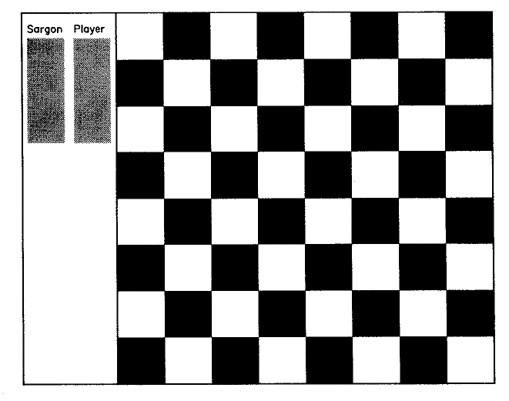 The empty board and move list area are displayed using the block move feature of the Z-80. It requires no stored data. The memory required to store the piece shapes has been kept to a minimum through use ofthe concept of boundary and kernel dots.  


### Graphics Characters

By varying and combining bits that are turned on, a total of 64 different graphics characters may be produced. For example:  
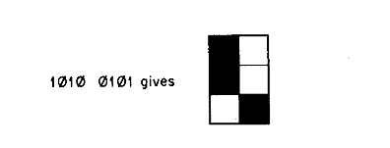  
Now, 1010 0101 = 165 in decimal, which can be used as the ASCII code for this character.

### Pillar and Bar Formatlnq

We've seen how individual dots are grouped into blocks of six dots each. The blocks are then laid out like tiles to cover the display area. So a dot matrix that is 12 x 12 would look like:  
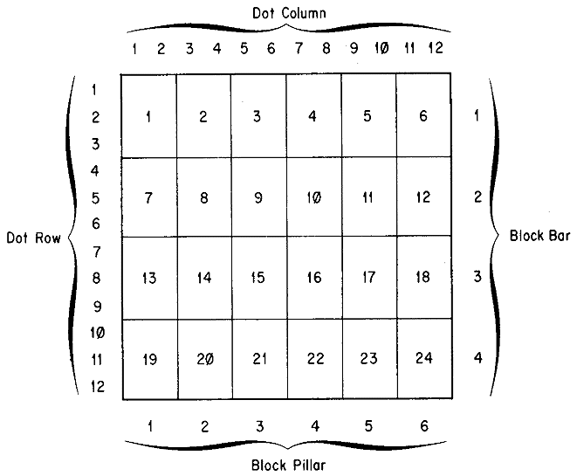

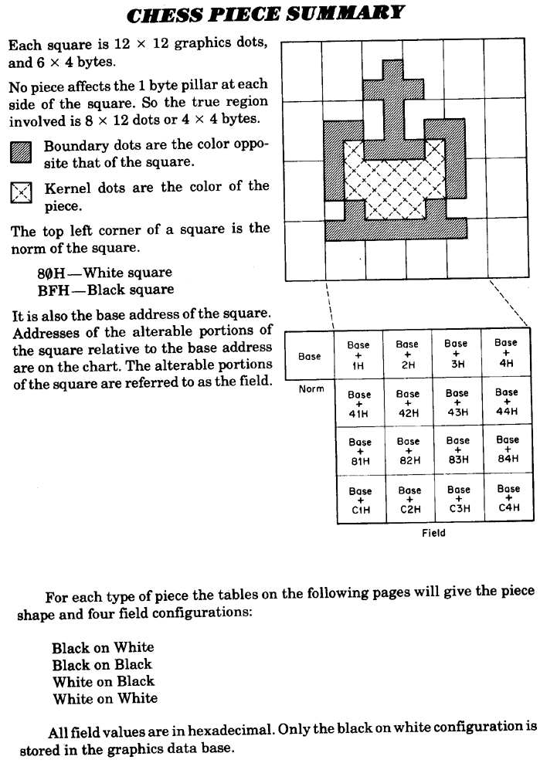

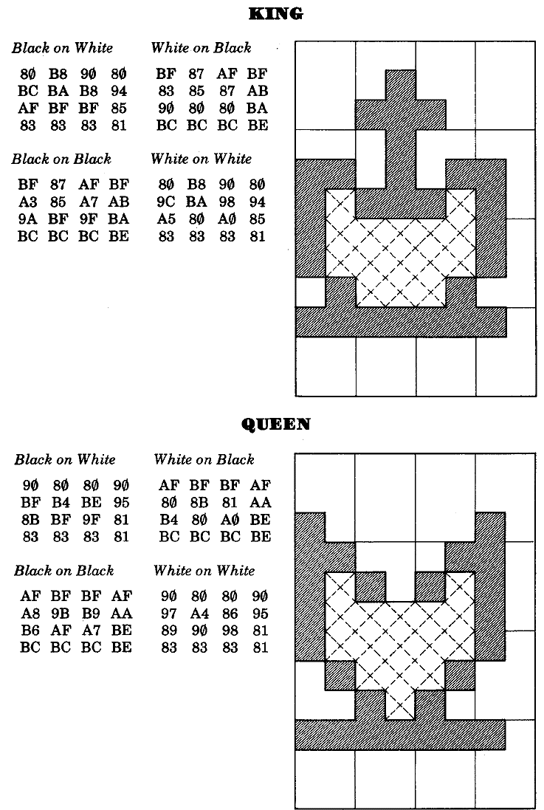

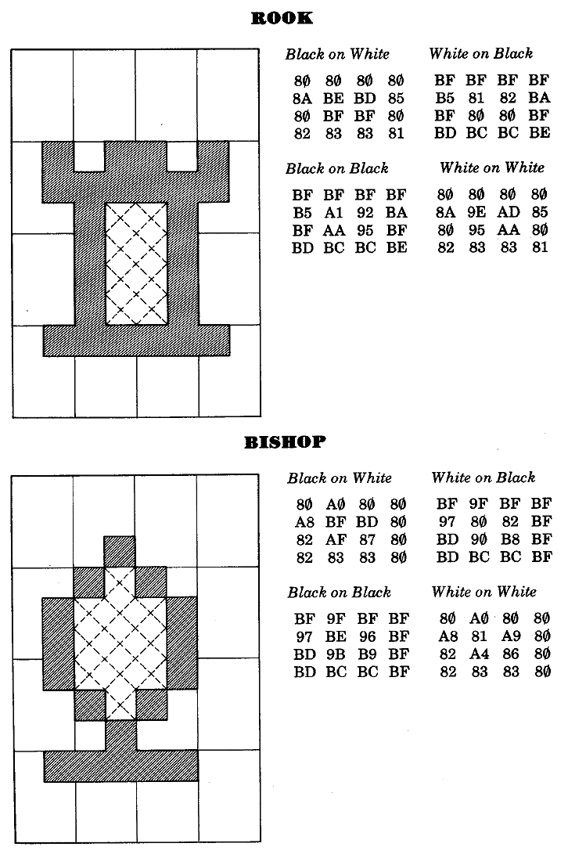

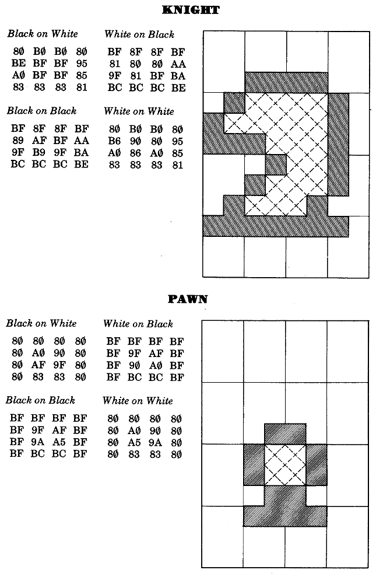

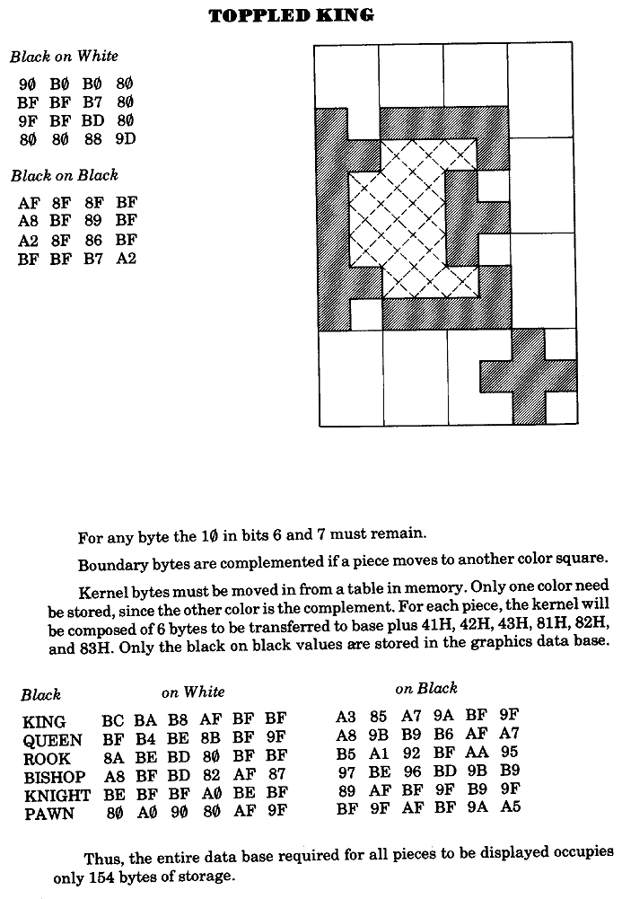

### User's Guide to SARGON

1. To begin execution:

The start address of SARGON will vary depnding on the load address. It will always be the address of DRIVER. Once execution has begiun, SARGON will ask you a series of queations:

"Welcome to Chess. Care for a Game?"

To playa game of chess respond with "y." An answer of "n" will get you to the routine that allows you to set up a boats position. (See Item 5.)

"Would you like to play white (w) or black (b)?"

The player selects white by entering "w" or black by "b." Any other key defaults to black. White always moves first.

"Select look ahead (1-6),"

This allows the player to select the depth of search. For example, if you select 3 ply, SARGON will consider:

* 1. All of his possible moves.
  2. All of your responses to those move,.
  3. All of his possible replies to your responses.

At this point, the boats display will appear on the screen. If you choose white, SARGON will be waiting for your move entry. If you choose black, SARGON will make its move on the board, print it in the move list, and then ..it for your move entry.

1. To enter a move:

Moves must be entered in algebraic these notation. This means you most tell SARGON the file and rank coordinates of the squares you are moving from and to. The files are lettered a-h and the ranks are numbered 1-8. So the coordinates of the board are:  
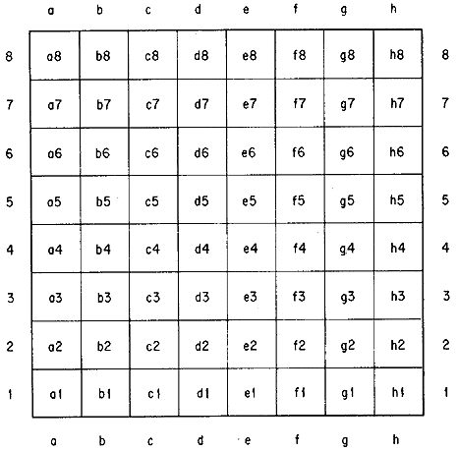

The move itself is entered as ff-tt so to play the king's pawn up two squares you would enter:

"e2-e4"

If SARGON responded with the same move, it would print:

"e7-e5"

<h3<="" h3=""></h3

Just enter the king's move. The rook will tag along. for example, if you are white and you wish to castle king's side, enter:

"e1-g1"

You will see both your king and rook move. When SARGON castles, he lists it as 0-0 or 0-0-0 as in normal chess notation.

### To Capture En Passant

if you wish to capture one of SARGON's pawns using the en passant privilege, enter your pawn's move. After your pawn move is displayed, SARGON's pawn will blink and then vanish. When SARGON captures en peasant, his move is displayed on the graphics board in the same way. SARGON prints it in the move list as PxPep.

1. To play another game after checkmate:

If either your or SARGON is checkmated, and you wish to play againk just hit any key. The screen will blank out and SARGON will ask:

"Care for Another Came?"

Replies to this question are just like those to the original l"Care for a Game?"

1. To resign a hopless game or take back a move:

Ifyou decide your position is hopeless, or you wish to change a move entered in error, first wait until it is your turn to move. Then enter "control-R." You will immediately get the "Care for Another Game?" question. If you want to start over, type "y," but if you want to correct the board display, type "n." You will then get the routine that allows you to setup a board position.

1. To setup or correct a board position: If you typed "n". a "Care for a Game" question, SARGON will now ask:

"Would you like to analyse a position?"

If you answer "n" to this one, you will be out of SARGON entirely and back in the computer's monitor state. An answer of "y" will display the board just as you left it. The lower left-hand corner will blink. That, your signal that you can change the contents of that square, using one of the analysis commands.

### Summary of Analysis Commands

<:CR>  
A carriage return leaves the contents of the square unchanged and blinks the next square. If you are already at the upper right-hand corner, it wraps around to the lower left-hand corner and blink, that square.

Backspace  
A backspace leaves the contents of the square unchanged and blinks.. square in the other direction. If, the opposite of a <:CR>, so you can go either direction.

0  
An entry of 0, or of the space bar, or any key not listed in these commands will empty the square.

"Enter a Piece"  
To enter a piece, type in piece-code, color-code, moved-code.

Piece-code is a letter indicating the desired piece (upper or lower case):

K -- King

Q -- Queen

R -- Rook

B -- Bishop

N -- Knight

P -- Pawn

Color-code is a letter indicating the side the piece belongs to (also upper or lower case):

w -- white

b -- black

Moved-code is a number indicating whether the Piece has moved or not:

0 - Piece has never moved

1 - piece has moved

Some examples:

To enter a black pawn on its original square type:

"P,b,0"

A white knight in the middle of the board would be:

"N,w,1"

A black king on its original square which has however moved:

"K,b,1"

Escape  
The wscape key will terminate the blinking cycle. SARGON will ask:

"Is this right?"

An answer pf "n" wo;; gp bacl tp setting up the board. If you say "y" then SARGON will ask for information it needs to resume play from this point. The color chooice and search depth questions are the same as in Section 1. In addition SARGON must be given the answer to:

"Whose move is it?"

1. To terminate execution:

The way out of the SARGON program depend, on whether you're at the end of a game, in the middle of a game, or setting up a board position.

At the end of a game:

* 1. Depress any key.
  2. SARGON responds with: "Care for Another Game?"
  3. Answer with "n."
  4. SARGON responds with: "Would you like to analyze a position?"
  5. Answer with "n" and you're out.

In the middle of a game:

* 1. Wait until it's your turn.
  2. Enter "Control-R"
  3. SARGON responds with: "Care for Another Game?"
  4. Follow 3-5 as for the end of a game.

Setting up a board:

* 1. Depress the escape key.
  2. SARGON answers: "R this right?"
  3. Respond with nswering four questions at once.
  4. Follow 2-4 as for the middle of a game.

### Notes on the Implementation of SARGON

1. SARGON was assembled using the TDL Macro Assembler, which does not use the ZILOG mnemonics. Conversion to ZILOG mnemonic, can be performed on instruction for instruction basis using the conversion chart included with this listing.
2. I/0 is based on the JOVE operation system which runs en the Wave-Mate Jupiter III computer. For ease in conversion all I/0 has been isolated to the following areas: Accept Input Character (p. 82), I/O Macro Definitions (p. 68), and Set Up Empty Board (p. 89).
3. SARGON must be loaded at a start address which is an even 256 byte page boundary (that is, at an address of the form XXOO hexadecimal).
4. Graphics routines assume a 96 by 128 dot matrix with black characters on a white background. To convert to a display with white character, on a black background, only six lines of code need be changed:

|  |  |  |
| --- | --- | --- |
| Location | Is | Change to |
| DB04 | MVI M,80H | MVI M,OBFH |
| DB08 | MVI M,OBFH | MVI M,80H |
| 2 lines above IP04 | JRZ IP04 | JRNZ IP04 |
| 4 lines above IP18 | JRNZ IPI8 | JRZ IP18 |
| 2 lines above IP18 | JRNZ IP2C | JRZ IP2C |
| 1 line below IP18 | JRZ IP2C | JRNZ IP2C |

1. SARGON requires a minimum of 8K bytes of memory available for user programs.

[Image of page 19 for reference](http://web.archive.org/web/20021012231845/madscientistroom.org/chm/Sargon-019.gif)

;*******************************************************************************

; SARGON

;

; Sargon is a computer chess playing program designed and coded by Dan and

; Kathe Spracklen,

; Copyright 1978. All rights reserved. No part of this publication may be

; reproduced without the prior

; written permission.

;

;*******************************************************************************

; EQUATES

;*******************************************************************************

;

PAWN = 1

KNIGHT = 2

BISHOP = 3

ROOK a 4

QUEEN = 5

KING = 6

WHITE - 0

BLACK = 80H

BPAWN - BLACK+PAWN

;*******************************************************************************

; TABLES SECTION

;*******************************************************************************

START

.LOC START+80H

TBASE = START+100H

;*******************************************************************************

; DIRECT -- Direction Table. Used to determine the direction of movement of

; each piece.

;*******************************************************************************

DIRECT - .-TBASE

.BYTE +09,+11,-11,-09

.BYTE +10,-10,+01,-01

.BYTE -21,-12,+08,+19

.BYTE +21,+12,-08,-19

.BYTE +10,+10,+11,+09

.BYTE -10,-10,-11,-09

[Image of page 20 for reference](http://web.archive.org/web/20021012231845/madscientistroom.org/chm/Sargon-020.gif)

; *******************************************************

; DPOINT -- Direction Table. Pointer. Used to determine.

; where to begin in the direction table for any

; given piece.

; *******************************************************

DPOINT = .-TBASE

.BYTE 20,16,8,0,4,0,0

; *******************************************************

; DCOUNT -- Direction Table Counter. Used to determine,

; the number of directions of movement for any

; given piece.

; *******************************************************

DCOUNT = -TBASE

.BYTE 4,4,8,4,4,8,8

; *******************************************************

; PVALUE -- Point Value. Gives the point value of each

; piece, or the worth of each piece.

; *******************************************************

PVALUE = .-TBASE-1

.BYTE 1,3,3,5,9,10

; *******************************************************

; PIECES -- The initial arrangement of the first rank of

; pieces on the board. Use to set up the board

; for the start of the game.

; *******************************************************

PIECES = .-TBASE

.BYTE 4,2,3,5,6,3,2,4

[Image of page 21 for reference](http://web.archive.org/web/20021012231845/madscientistroom.org/chm/Sargon-021.gif)

; *******************************************************

; BOARD -- Board Array. Used to hold the current position

; of the board during play. The board itself

; looks like:

; FFFFFFFFFFFFFFFFFFFF

; FFFFFFFFFFFFFFFFFFFF

; FF0402030506030204FF

; FF0101010101010101FF

; FF0000000000000000FF

; FF0000000000000000FF

; FF0000000000000060FF

; FF0000000000000000FF

; FF8181818181818181FF

; FF8482838586838284FF

; FFFFFFFFFFFFFFFFFFFF

; FFFFFFFFFFFFFFFFFFFF

; The values of FF form the border of the

; board, and are used to indicate when a piece

; moves off the board. The individual bits of

; the other bytes in the board array are as

; follows:

; Bit 7 -- Color of the piece

; 1 -- Black

; 0 -- White

; Bit 6 -- Not used

; Bit 5 -- Not used

; Bit 4 --Castle flag for Kings only

; Bit 3 -- Piece has moved flag

; Bits 2-0 Piece type

; 1 -- Pawn

; 2 -- Knight

; 3 -- Bishop

; 4 -- Rook

; 5 -- Queen

; 6 -- King

; 7 -- Not used

; 0 -- Empty Square

; *******************************************************

BOARD = .-TBASE

BOARDA: BLKB 120

[Image of page 22 for reference](http://web.archive.org/web/20021012231845/madscientistroom.org/chm/Sargon-022.gif)

; *******************************************************

; ATKLIST -- Attack List. A two part array, the first

; half for white and the second half for black.

; It is used to hold the attackers of any given

; square in the order of their value.

; WACT -- White Attack Count. This is the first

; byte of the array and tells how many pieces are

; in the white portion of the attack list.

; BACT -- Black Attack Count. This is the eighth byte of

; the array and does the same for black.

; *******************************************************

WACT = ATKLST

BACT = ATKLST+7

ATKLST: WORD 0,0,0,0,0,0,0

; *******************************************************

; PLIST -- Pinned Piece Array. This is a two part array.

; PLISTA contains the pinned piece position.

; PLISTD contains the direction from the pinned

; piece to the attacker.

; *******************************************************

PLIST = .-TBASE-1

PLISTD = PLIST+10

PLISTA: WORD 0,0,0,0,0,0,0,0,0,0

; *******************************************************

; POSK -- Position of Kings. A two byte area, the first

; byte of which hold the position of the white

; king and the second holding the position of

; the black king.

; POSQ -- Position of Queens. Like POSK,but for queens.

; *******************************************************

POSK: BYTE 24,95

POSQ: BYTE 14,94

.BYTE -1

[Image of page 23 for reference](http://web.archive.org/web/20021012231845/madscientistroom.org/chm/Sargon-023.gif)

; *******************************************************

; SCORE -- Score Array. Used during Alpha-Beta pruning to

; hold the scores at each ply. It includes two

; "dummy" entries for ply -1 and ply 0.

; *******************************************************

SCORE: WORD 0,0,0,0,0,0

; *******************************************************

; PLYIX -- Ply Table. Contains pairs of pointers, a pair

; for each ply. The first pointer points to the

; top of the list of possible moves at that ply.

; The second pointer points to which move in the

; list is the one currently being considered.

; *******************************************************

PLYIX: WORD 0,0,0,0,0,0,0,0,0,0

.WORD 0,0,0,0,0,0,0,0,0,0

STACK -- Contains the stack for the program.

.LOC START+2FFH

STACK:

[Image of page 24 for reference](http://web.archive.org/web/20021012231845/madscientistroom.org/chm/Sargon-024.gif)

; *******************************************************

; TABLE INDICES SECTION

; Ml-M4 -- Working indices used to index into

; the board array.

; Tl-T3 -- Working indices used to index into Direction

; Count, Direction Value, and Piece Value tables.

; INDX1 -- General working indices. Used for various

; INDX2 purposes.

; NPINS -- Number of Pins. Count and pointer into the

; pinned piece list.

; MLPTRI -- Pointer into the ply table which tells

; which pair of pointers are in current use.

; MLPTRJ -- Pointer into the move list to the move that is

; currently being processed.

:

; SCRIX -- Score Index. Pointer to the score table for

; the ply being examined.

; BESTM -- Pointer into the move list for the move that

; is currently considered the best by the

; Alpha-Beta pruning process.

; MLLST -- Pointer to the previous move placed in the move

; list. Used during generation of the move list.

; MLNXT -- Pointer to the next available space in the move

; *******************************************************

.LOC START+O

Ml: WORD TBASE

M2: WORD TBASE

M3: WORD TBASE

M4: WORD TBASE

Tl: WORD TBASE

T2: WORD TBASE

T3: WORD TBASE

INDX1: WORD TBASE

INDX2: WORD TBASE

NPINS: WORD TBASE

MLPTRI: WORD PLYIX

MLPTRJ: WORD 0

SCRIX: WORD 0

BESTM: WORD 0

MLLST: WORD 0

MLNXT: WORD MLLST

[Image of page 25 for reference](http://web.archive.org/web/20021012231845/madscientistroom.org/chm/Sargon-025.gif)

; *******************************************************

; VARIABLES SECTION

; KOLOR -- Indicates computer's color. White is 0, and

; Black is 80H.

; COLOR -- Indicates color of the side with the move.

; P1-P3 -- Working area to hold the contents of the board

; array for a given square.

; PMATE -- The move number at which a checkmate is

; discovered during look ahead.

; MOVENO -- Current move number.

; PLYMAX -- Maximum depth of search using Alpha-Beta

; pruning.

; NPLY -- Current ply number during Alpha-Beta

; pruning.

; CKFLG -- A non-zero value indicates the king is in check.

; MATEF -- A zero value indicates no legal moves.

; VALM -- The score of the current move being examined.

; BRDC -- A measure of mobility equal to the total number

; of squares white can move to minus the number

; black can move to.

; PTSL -- The maximum number of points which could be lost

; through an exchange by the player not on the

; move.

; PTSW1 -- The maximum number of points which could be won

; through an exchange by the player not on the

; move.

; PTSW2 -- The second highest number of points which could

; be won through a different exchange by the player

; not on the move.

; MTRL -- A measure of the difference in material

; currently on the board. It is the total value of

; the white pieces minus the total value of the

; black pieces.

; BC0 -- The value of board control(BRDC) at ply 0.

[Image of page 26 for reference](http://web.archive.org/web/20021012231845/madscientistroom.org/chm/Sargon-026.gif)

; MVO -- The value of material(MTRL) at ply 0.

; PTSCK -- A non-zero value indicates that the piece has

; just moved itself into a losing exchange of

; material.

; MOVES -- Our very tiny book of openings. Determines

; the first move for the computer.

; *******************************************************

KOLOR: BYTE 0

COLOR: BYTE 0

P1: BYTE 0

P2: BYTE 0

P3: BYTE 0

PMATE: BYTE 0

MOVENO: BYTE 0

PLYMAX: BYTE 2

NPLY: BYTE 0

CKFLG: BYTE 0

MATEF: BYTE 0

VALM: BYTE 0

BRDC: BYTE 0

PTSL: BYTE 0

PTSWl: BYTE 0

PTSW2: BYTE 0

MTRL: BYTE 0

BCO: BYTE 0

MVO: BYTE 0

PTSCK: BYTE 0

MOVES: BYTE 35,55,10H

.BYTE 34,54,10H

.BYTE 85,65,10H

.BYTE 84,64,10H

[Image of page 27 for reference](http://web.archive.org/web/20021012231845/madscientistroom.org/chm/Sargon-027.gif)

; *******************************************************

; MOVE LIST SECTION

; MUST -- A 2048 byte storage area for generated moves.

; This area must be large enough to hold all

; the moves for a single leg of the move tree.

; MLEND -- The address of the last available location

; in the move list.

; MLPTR -- The Move List is a linked list of individual

; moves each of which is 6 bytes in length. The

; move list pointer(MLPTR) is the link field

; within a move.

; MLFRP -- The field in the move entry which gives the

; board position from which the piece is moving.

; MLTOP -- The field in the move entry which gives the

; board position to which the piece is moving.

; MLFLG -- A field in the move entry which contains flag

; information. The meaning of each bit is as

; follows:

; Bit 7 -- The color of any captured piece

; 0 -- White

; 1 -- Black

; Bit 6 -- Double move flag (set for castling and

; en passant pawn captures)

; Bit 5 -- Pawn Promotion flag; set when pawn

; promotes.

; Bit 4 -- When set, this flag indicates that

; this is the first move for the

; piece on the move.

; Bit 3 -- This flag is set is there is a piece

; captured, and that piece has moved at

; least once.

; Bits 2-0 Describe the captured piece. A

; zero value indicates no capture.

; MLVAL -- The field in the move entry which contains the

; score assigned to the move.

; *******************************************************

[Image of page 28 for reference](http://web.archive.org/web/20021012231845/madscientistroom.org/chm/Sargon-028.gif)

.LOC START+300H

MLIST: BLKB 2048

MLEND = MLIST+2040

MLPTR = 0

MLFRP = 2

MLTOP = 3

MLFLG = 4

MLVAL = 5

; *******************************************************

PROGRAM CODE SECTION

BOARD SETUP ROUTINE

FUNCTION: To initialize the board array, setting the

pieces in their initial positions for the

start of the game.

CALLED BY: DRIVER

CALLS: None

ARGUMENTS: None

; *******************************************************

INITBD: MVI B,120 ; Pre-fill board with -1's

LXI H,BOARDA

MVI M,-1

INX H

DJNZ .-3

MVI B,8

LXI X,BOARDA

IB2: MOV A,-8(X) ; Fill non-border squares

MOV 21(X),A ; White pieces

SET 7,A ; Change to black

MOV 91(X),A ; Black pieces

MVI 31(X),PAWN ; White Pawns

MVI 81(X),BPAWN ; Black Pawns

MVI 41(X),0 ; Empty squares

MVI 51(X),0

MVI 61(X),0

MVI 71(X),0

INX X

DJNZ IB2

LXI X,POSK ; Init King/Queen position list

MVI 0(X),25

MVI 1(X),95

MVI 2(X),24

MVI 3(X),94

RET

[Image of page 29 for reference](http://web.archive.org/web/20021012231845/madscientistroom.org/chm/Sargon-029.gif)

; *******************************************************

; PATH ROUTINE

; *******************************************************

; FUNCTION: To generate a single possible move for a given

; piece along its current path of motion including:

; Fetching the contents of the board at the new

; position, and setting a flag describing the

; contents:

; 0 -- New postion is empty

; 1 -- Encountered a piece of the

; opposite color

; 2 -- Encountered a piece of the

; same color

; 3 -- New position is off the

; board

; CALLED BY: MPIECE

; ATTACK

; PINFND

; CALLS: None

; ARGUMENTS: Direction from the direction array giving the

; constant to be added for the new position.

; *******************************************************

PATH: LXI H,M2 ; Get previous position

MOV A,M

ADD C ; Add diection constant

MOV M,A ; Save new position

LIXD M2 ; Load board index

MOV A,BOARD(X) ; Get contents of board

CPI -1 ; In boarder area ?

JRZ PA2 ; Yes - jump

STA P2 ; Save piece

ANI 7 ; Clear flags

STA T2 ; Save piece type

RZ ; Return if empty .

LDA P2 ; Get piece encountered

LXI H,P1 ; Get moving piece address

XRA M ; Compare

BIT 7,A ; Do colors match ?

JRZ PA1 ; Yes - jump

MVI A,1 ; Set different color flag

RET ; Return

PA1: MVI A,2 ; Set same color flag

RET ; Return

PA2: MVI A,3 ; Set off board flag

RET ; Return

[Image of page 30 for reference](http://web.archive.org/web/20021012231845/madscientistroom.org/chm/Sargon-030.gif)

; **********************************************************************

;

; PIECE MOVER ROUTINE

;

; FUNCTION: To. generate all the possible legal moves for a given

; piece.

;

; CALLED BY: GENMOV

;

; CALLS: PATH

; ADMOVE

; CASTLE

; ENPSNT

;

; ARGUMENTS: The piece to be moved.

;

; **********************************************************************

MPIECE: XRA M ; Piece to move

ANI 87H ; Clear flag bit

CPI BPAWN ; Is is a black Pawn ?

JRNZ .+3 ; No-Skip

DCR A ; Decrement for black Pawns

ANI 7 ; Get piece type

STA T1 ; Save piece type

LIYD T1 ; Load index to DCOUNT/DPOINT

MOV B,DCOUNT(Y) ; Get direction count

MOV A,DPOINT(Y) ; Get direction pointer

STA INDX2 ; Save as index to direct

LIYD INDX2 ; Load index

MP5: MOV C,DIRECT(Y) ; Get move direction

LDA Ml ; From position

STA M2 ; Initialize to position

MP10: CALL PATH ; Calculate next position

CPI 2 ; Ready for new direction ?

JRNC MP15 ; Yes - Jump

ANA A ; Test for empty square

EXAF ; Save result

LDA T1 ; Get piece moved

CPI PAWN+1 ; Is it a Pawn ?

JRC MP20 ; Yes - Jump

CALL ADMOVE ; Add move to list

EXAF ; Empty square ?

JRNZ MP15 ; No - Jump

LDA Tl ; Piece type

CPI KING ; King ?

JRZ MP15 : Yes - Jump

CPI BISHOP ; Bishop, Rook, or Queen ?

JRNC MP10 ; Yes - Jump

MP15: INX Y ; Increment direction index

DJNZ MP5 ; Decr. count-jump if non-zerc

LDA T1 ; Piece type

[Image of page 31 for reference](http://web.archive.org/web/20021012231845/madscientistroom.org/chm/Sargon-031.gif)

CPI KING ; King ?

CZ CASTLE ; Yes - Try Castling

RET ; Return

; ***** PAWN LOGIC *****

MP20: MOV A,B ; Counter for direction

CPI 3 ; On diagonal moves ?

JRC MP35 ; Yes - Jump

JRZ MP30 ; -or-jump if on 2 square move

EXAF ; Is forward square empty?

JRNZ MP15 ; No - jump

LDA M2 ; Get "to" position

CPI 91 ; Promote white Pawn ?

JRNC MP25 ; Yes - Jump

CPI 29 ; Promote black Pawn ?

JRNC MP26 ; No - Jump

MP25: LXI H,P2 ; Flag address

SET 5,M ; Set promote flag

MP26: CALL ADMOVE ; Add to move list

INX Y ; Adjust to two square move

DCR B

LXI H,P1 ; Check Pawn moved flag

BIT 3,M ; Has it moved before ?

JRZ MP10 ; No - Jump

JMP MP15 ; Jump

MP30: EXAF ; Is forward square empty ?

JRNZ MP15 ; No - Jump

MP31: CALL ADMOVE ; Add to move list

JMP MP15 ; Jump

MP35: EXAF ; Is diagonal square empty ?

JRZ MP36 ; Yes - Jump

LDA M2 ; Get "to" position

CPI 91 ; Promote white Pawn ?

JRNC MP37 ; Yes - Jump

CPI 29 ; Black Pawn promotion ?

JRNC MP31 ; No- Jump

MP37: LXI H,P2 ; Get flag address

SET 5,M ; Set promote flag

JMPR MP31 ; Jump

MP36: CALL ENPSNT ; Try en passant capture

JMP MP15 ; Jump

[Image of page 32 for reference](http://web.archive.org/web/20021012231845/madscientistroom.org/chm/Sargon-032.gif)

; xxxxxxxxxxxxxxxxxxxxxxxxxxxxxxxxxxxxxx**xxxxxxxxxxxxxxxxxxx

; EN PASSANT ROUTINE

; xxxxxxxxxxxxxxxxxxxxxxxxxxxxxxxxxxxxxxxxxxxxxxxxxxxxxxxxxxx

; FUNCTION: -- To test for en passant Pawn capture and

; to add it to the move list if it is

; legal.

; CALLED BY: -- MPIECE

; CALLS: -- ADMOVE

;

; ADJPTR

;

; ARGUMENTS: -- None

; xxxxxxxxxxxxxxxxxxxxxxxxxxxxxxxxxxxxxxxxxxxxxxxxxxxxxxxxxxxx

ENPSNT: LDA M1 ; Set position of Pawn

LXI H,P1 ; Check color

BIT 7,M ; Is it white ?

JRZ .+4 ; Yes - skip

ADI 10 ; Add 10 for black

CPI 61 ; On en passant capture rank ?

RNC ; No - return

CPI 69 ; On en passant capture rank ?

RNC ; No - return

LIXD MLPTRJ ; Get pointer to previous move

BIT 4,MLFLG(X) ; First move for that piece ?

RZ ; No - return

MOV A,MLTOP(X) ; Get "to" postition

STA M4 ; Store as index to board

LIXD M4 ; Load board index

MOV A,BOARD(X) ; Get piece moved

STA P3 ; Save it

ANI 7 ; Get piece type

CPI PAWN ; Is it a Pawn ?

RNZ ; No - return

LDA M4 ; Get "to" position

LXI H,M2 ; Get present "to" position

SUB M ; Find difference

JP .+5 ; Positive ? Yes - Jump

NEG ; Else take absolute value

CPI 10 ; Is difference 10 ?

RNZ ; No - return

LXI H,P2 ; Address of flags

SET 6,M ; Set double move flag

CALL ADMOVE ; Add Pawn move to move list

LDA M1 ; Save initial Pawn position

STA M3

LDA M4 ; Set "from" and "to" position8

for dummy move

[Image of page 33 for reference](http://web.archive.org/web/20021012231845/madscientistroom.org/chm/Sargon-033.gif)

STA M1

STA M2

LDA P3 ; Save captured Pawn

STA P2

CALL ADMOVE ; Add Pawn capture to move list

LDA M3 ; Restore "from" position

STA M1

; **********************************************************************

; ADJUST MOVE LIST POINTER FOR DOUBLE MOVE

;

; FUNCTION: -- To adjust move list pointer to link around

; second move in double move.

;

; CALLED BY: -- ENPSNT

; CASTLE

; (This mini-routine is not really called,

; but is jumped to to save time.)

;

; CALLS: -- None

;

; ARGUMENTS: -- None

;

; **********************************************************************

ADJPTR: LHLD MLLST ; Get list pointer

LXI D,-6 ; Size of a move entry

DAD D ; Back up list pointer

SHLD MLLST ; Save list pointer

MVI M,0 ; Zero out link, first byte

INX H ; Next byte

MVI M,0 ; Zero out link, second byte

RET ; Return

[Image of page 34 for reference](http://web.archive.org/web/20021012231845/madscientistroom.org/chm/Sargon-034.gif)

; **********************************************************************

; CASTLE ROUTINE

;

; FUNCTION: -- To determine whether castling is legal

; (Queen side, King side, or both) and add it

; to the move list if it is.

;

; CALLED BY: -- MPIECE

;

; CALLS: -- ATTACK

; ADMOVE

; ADJPTR

;

; ARGUMENTS: -- None

;

; **********************************************************************

CASTLE: LDA P1 ; Get King

BIT 3,A ; Has it moved ?

RNZ ; Yes - return

LDA CKFLG ; Fetch Check Flag

ANA A ; Is the King in check ?

RNZ ; Yes - Return

LXI B,OFF03H ; Initialize King-side values

CA5: LDA M1 ; King position

ADD C ; Rook position

MOV C,A ; Save

STA M3 ; Store as board index

LIXD M3 ; Load board index

MOV A,BOARD(X) ; Get contents of board

ANI 7FH ; Clear color bit

CPI ROOK ; Has Rook ever moved ?

JRNZ CA20 ; Yes - Jump

MOV A,C ; Restore Rook position

JMPR CA15 ; Jump

CA10: LIXD M3 ; Load board index

MOV A,BOARD(X) ; Get contents of board

ANA A ; Empty ?

JRNZ CA20 ; No - Jump

LDA M3 ; Current position

CPI 22 ; Wh.ite Queen Knight square ?

JRZ CA15 ; Yes - Jump

CPI 92 ; Black Queen Knight square ?

JRZ CA15 ; Yes - Jump

CALL ATTACK ; Look for attack on square

ANA A ; Any attackers ?

JRNZ CA20 ; Yes - Jump

LDA M3 ; Current position

CA15: ADD B ; Next position

STA M3 ; Save as board index

LXI H,M1 ; King position

CMP M ; Reached King ?

[Image of page 35 for reference](http://web.archive.org/web/20021012231845/madscientistroom.org/chm/Sargon-035.gif)

JRNZ CA10 ; No - jump

SUB B ; Determine King's position

SUB B

STA M2 ; Save it

LXI H,P2 ; Address of flags

MVI M,40H ; Set double move flag

CALL ADMOVE ; Put king move in list

LXI H,M1 ; Addr of King "from" position

MOV A,M ; Get King's "from" position

MOV M,C ; Store Rook "from" position

SUB B ; Get Rook "to" position

STA M2 ; Store Rook "to" position

XRA A ; Zero

STA P2 ; Zero move flags

CALL ADMOVE ; Put Rook move in list

CALL ADJPTR ; Re-adjust move list pointer

LDA M3 ; Restore King position

STA M1 ; Store

CA20: MOV AFB ; Scan Index

CPI 1 ; Done ?

RZ ; Yes - return

LXI B,01FCH ; Set Queen-side initial values

JMP CA5 ; Jump

[Image of page 36 for reference](http://web.archive.org/web/20021012231845/madscientistroom.org/chm/Sargon-036.gif)

; xxxxxxxxxxxxxxxxxxxxxxxxxxxxxxxxxxxxxxxxxxxxxxxxxxxxxxxxxxxx

; ADMOVE ROUTINE

; xxxxxxxxxxxxxxxxxxxxxxxxxxxxxxxxxxxxxxxxxxxxxxxxxxxxxxxxxxxx

; FUNCTION: -- To add a move to the move list

;

; CALLED BY: -- MPIECE

; ENPSNT

; CASTLE

;

; CALLS: -- None

;

; ARGUMENT: -- None

; **x***x*x*xx*xxxx*xxxxxxxxxxxxxxxxxxxxxxxxxxxxxxxxxxxxxxxxxxx

ADMOVE: LDED MLNXT ; Addr of next loc in move list

LXI H,MLEND ; Address of list end

ANA A ; Clear carry flag

DSBC D ; Calculate difference

JRC AM10 ; Jump if out of space

LHLD MLLST ; Addr of prev. list area

SDED MLLST ; Savn next as previous

MOV M,E ; Store link address

INX H

MOV M,D

LXI H,Pl ; Address of moved piece

BIT 3,M ; Has it moved before ?

JRNZ .+7 ; Yes - jump

LXI H,P2 ; Address of move flags

SET 4,M ; Set first move flag

XCHG ; Address of move area

MVI M,0 ; Store zero in link address

INX H

MVI M,0

INX H

LDA Ml ; Store "from" move position

MOV M,A

INX H

LDA M2 ; Store "to" move position

MOV M,A

INX H

LDA P2 ; Store move flags/capt. piece

MOV M,A

INX H

MVI M,0 ; Store initial move value

INX H

SHLD MLNXT ; Save address for next move

RET ; Return

AM10: MVI M,0 ; Abort entry on table ovflow

INX H

MVI M,0

DCX H

RET

[Image of page 37 for reference](http://web.archive.org/web/20021012231845/madscientistroom.org/chm/Sargon-037.gif)

; **xxxxxx*x**xxxxx*xxx*xxxx*xxx*xxxxxxxxxxxx*xxxxxxxxxxxxx*xx

; GENERATE MOVE ROUTINE

; xxx*xx*x**xxxxxxx**xxxxxxxxx**x***x**xx*x*xx***x*x**x*xxxx*x

; FUNCTION: -- To generate the move set for all of the

; pieces of a given color.

; CALLED BY: -- FNDMOV

; CALLS: -- MIECE

; INCHK

; ARGUMENTS: -- None

; xxxxxxxxxxxxxxx*x*xxxx*xxxx*xxxx*xx*xxxxxxx*xxxxxxxxxx***x*x

GENMOV: CALL INCHK ; Test for King in check

STA CKFLG ; Save attack count as flag

LDED MLNXT ; Addr of next avail list space

LHLD MLPTRI ; Ply list pointer index

INX H ; Increment to next ply

INX H

MOV M,E\ ; Save move list pointer

INX H

MOV M,D

INX H

SHLD MLPTRI ; Save new index

SHLD MLLST ; Last pointer for chain init.

MVI A,21 ; First position on board

GM5: STA M1 ; Save as index

LIXD Ml ; Load board index

MOV A,BOARD(X) ; Fetch board contents

ANA A ; Is it empty ?

JRZ GM10 ; Yes - Jump

CPI -1 ; Is it a boarder square ?

JRZ GM10 ; Yes - Jump

STA P1 ; Save piece

LXI H,COLOR ; Address of color of piece

XRA M ; Test color of piece

BIT 7,A ; Match ?

CZ MPIECE ; Yes - call Move Piece

GM10: LDA M1 ; Fetch current board position

INR A ; Incr to next board position

CPI 99 ; End of board array ?

JNZ GM5 ; No - Jump

RET ; Return

[Image of page 38 for reference](http://web.archive.org/web/20021012231845/madscientistroom.org/chm/Sargon-038.gif)

; xxxxxxxxxxxxxxxxxxxxxx*xxxxxxxxxxxxxxxxxxxxxxxxxxxxxxxxxxxxx

; CHECK ROUTINE

; xxxx*xxxxxxxxxxxxxxx-x*x*xxxxxxxxxxxxxx*xxxxxxxxxxxxxxxxxxxxx

; FUNCTION: -- To determine whether or not the

; King is in check.

; CALLED BY: -- GENMOV

; FNDMOV

; EVAL

; CALLS: -- ATTACK

;

; ARGUMENTS: -- Color of King

; x****xxx*xs**xxxxxxxxxxxxxxxxxxxxxxxxxxxxxxxxxxxxxxxxxxxxxxx

INCHK: LDA COLOR ; Get color

INCHK1: LXI H,POSK ; Addr of white King position

ANA A ; White ?

JRZ .+3 ; Yes - Skip

INX H ; Addr of black King position

MOV A,M ; Fetch King position

STA M3 ; Save

LIXD M3 ; Load board index

MOV A,BOARD(X) ; Fetch board contents

STA P1 ; Save

ANI 7 ; Get piece type

STA T1 ; Save

CALL ATTACK ; Look for attackers on King

RET ; Return

[Image of page 39 for reference](http://web.archive.org/web/20021012231845/madscientistroom.org/chm/Sargon-039.gif)

; ************************************************************

; ATTACK ROUTINE

; **************************************************************

; FUNCTION: -- To find all attackers on a given square

; by scanning outward from the square

; until a piece is found that attacks

; that,square, or a piece is found that

; doesn't attack that square, or the edge

; of the board is reached.

;

; In determining which pieces attack a square,

; this routine also takes into account the ability of

; certain pieces to attack through another attacking

; piece. (For example a queen lined up behind a bishop

; of her same color along a diagonal.) The bishop is

; then said to be transparent to the queen, since both

; participate in the attack.

;

; In the case where this routine is called by

; CASTLE or INCHK, the routine is terminated as soon as

; an attacker of the opposite color is encountered.

;

; CALLED BY: -- POINTS

; PINFND

; CASTLE

; INCHK

;

; CALLS: -- PATH

; ATKSAV

;

; ARGUMENTS: -- None

; **************************************************************

ATTACK: PUSH B ; Save Register B

XRA A ; Clear

MVI B,16 ; Initial direction count

STA INDX2 ; Initial direction index

LIYD INDX2 ; Load index

AT5: MOV C,DIRECT(Y) ; Get direction

MVI D,0 ; Init. scan count/flags

LDA M3 ; Init. board start position

STA M2 ; Save

AT10: INR D ; Increment scan count

CALL PATH ; Next position

CPI 1 ; Piece of a opposite color ?

JRZ AT14A ; Yes - jump

CPI 2 ; Piece of same color ?

JRZ AT14B ; Yes - jump

[Image of page 40 for reference](http://web.archive.org/web/20021012231845/madscientistroom.org/chm/Sargon-040.gif)

ANA A ; Empty position ?

JRNZ AT12 ; No - jump

MOV A,B ; Fetch direction count

CPI 9 ; On knight scan ?

JRNC AT10 ; No - jump

AT12: INX Y ; Increment direction index

DJNZ AT5 ; Done ? No - jump

XRA A ; No attackers

AT13: POP B ; Restore register B

RET ; Return

AT14A: BIT 6,D ; Same color found already ?

JRNZ AT12 ; Yes - jump

SET 5,D ; Set opposite color found flag

JMP AT14 ; Jump

AT14B: BIT 5,D ; Opposite color found already?

JRNZ AT12 ; Yes - jump

SET 6,D ; Set same color found flag

; ***** DETERMINE IF PIECE ENCOUNTERED ATTACKS SQUARE *****

AT14: LDA T2 ; Fetch piece type encountered

MOV E,A ; Save

MOV A,B ; Get direction-counter

CPI 9 ; Look for Knights ?

JRC AT25 ; Yes - jump

MOV A,E ; Get piece type

CPI QUEEN ; Is is a Queen ?

JRNZ AT15 ; No - Jump

SET 7,D ; Set Queen found flag

JMPR AT30 ; Jump

AT15: MOV A,D ; Get flag/scan count

ANI OFH ; Isolate count

CPI 1 ; On first position ?

JRNZ AT16 ; No - jump

MOV A,E ; Get encountered piece type

CPI KING ; Is it a King ?

JRZ AT30 ; Yes - jump

AT16: MOV A,B ; Get direction counter

CPI 13 ; Scanning files or ranks ?

JRC AT21 ; Yes - jump

MOV A,E ; Get piece type

CPI BISHOP ; Is it a Bishop ?

JRZ AT30 ; Yes - jump

MOV A,D ; Get flags/scan count

ANI OFH ; Isolate count

CPI 1 ; On first position ?

JRNZ AT12 ; No - jump

CMP E ; Is it a Pawn ?

JRNZ AT12 ; No - jump

LDA P2 ; Fetch piece including color

[Image of page 41 for reference](http://web.archive.org/web/20021012231845/madscientistroom.org/chm/Sargon-041.gif)

BIT 7,A ; Is it white ?

JRZ AT20 ; Yes - jump

MOV A,B ; Get direction counter

CPI 15 ; On a non-attacking diagonal ?

JRC AT12 ; Yes - jump

JMPR AT30 ; Jump

AT20: MOV A,B ; Get direction counter

CPI 15 ; On a non-attacking diagonal ?

JRNC AT12 ; Yes - jump

JMPR AT30 ; Jump

AT21: MOV A,E ; Get piece type

CPI ROOK ; Is is a Rook ?

JRNZ AT12 ; No - jump

JMPR AT30 ; Jump

AT25: MOV A,E ; Get piece type

CPI KNIGHT ; Is it a Knight ?

JRNZ AT12 ; No - jump

AT30: LDA T1 ; Attacked piece type/flag

CPI 7 ; Call from POINTS ?

JRZ AT31 ; Yes - jump

BIT 5,D ; Is attacker opposite color ?

JRZ AT32 ; No - jump

MVI A,1 ; Set attacker found flag

JMP AT13 ; Jump

AT31: CALL ATKSAV ; Save attacker in attack list

AT32: LDA T2 ; Attacking piece type

CPI KING ; Is it a King,?

JZ AT12 ; Yes - jump

CPI KNIGHT ; Is it a Knight ?

JZ AT12 ; Yes - jump

JMP AT10 ; Jump

[Image of page 42 for reference](http://web.archive.org/web/20021012231845/madscientistroom.org/chm/Sargon-042.gif)

; *************************************************************

; ATTACK SAVE ROUTINE

; *************************************************************

; FUNCTION: -- To save an attacking piece value in the attack

; list, and to increment the attack count for that

; color piece.

;

; The pin piece list is checked for the attacking

; piece, and if found there, the piece is not

; included in the attack list.

;

; CALLED BY: -- ATTACK

;

; CALLS: -- PNCK

;

; ARGUMENTS: -- None

; *************************************************************

ATKSAV: PUSH B ; Save Regs BC

PUSH D ; Save Regs DE

LDA NPINS ; Number of pinned pieces

ANA A ; Any ?

CNZ PNCK ; yes - check pin list

LIXD T2 ; Init index to value table

LXI H,ATKLST ; Init address of attack list

LXI B,0 ; Init increment for white

LDA P2 ; Attacking piece

BIT 7,A ; Is it white ?

JRZ .+4 ; Yes - jump

MVI C,7 ; Init increment for black

ANI 7 ; Attacking piece type

MOV E,A ; Init increment for type

BIT 7,D ; Queen found this scan ?

JRZ .+4 ; No - jump

MVI E,QUEEN ; Use Queen slot in attack list

DAD B ; Attack list address

INR M ; Increment list count

MVI D,0

DAD D ; Attack list slot address

MOV A,M ; Get data already there

ANI OFH ; Is first slot empty ?

JRZ AS20 ; Yes - jump

MOV A,M ; Get data again

ANI OFOH ; Is second slot empty ?

JRZ AS19 ; Yes - jump

INX H ; Increment to King slot

JMPR AS20 ; Jump

AS19: RLD ; Temp save lower in upper

MOV A,PVALUE(X) ; Get new value for attack list

RRD ; Put in 2nd attack list slot

JMPR AS25 ; Jump

AS20: MOV A,PVALUE(X) ; Get new value for attack list

RLD ; Put in 1st attack list slot

[Image of page 43 for reference](http://web.archive.org/web/20021012231845/madscientistroom.org/chm/Sargon-043.gif)

AS25: POP D ; Restore DE regs

POP B ; Restore BC regs

RET ; Return

; xxxxxxxxxxxxxxxxxxxxxxxxxxxxxxxxxxxxxxxxxxxxxxxxxxxxxxxxxxxx

; PIN CHECK ROUTINE

; xxxxxxxxxxxxxxxxxxxxxxxxxxxxxxxxxxxxxxxxxxxxxxxxxxxxxxxxxxxx

; FUNCTION: -- Checks to see if the attacker is in the

; pinned piece list. If so he is not a valid

; attacker unless the direction in which he

; attacks in the same as the direction along

; which he is pinned. If the piece is

; found to be invalid as an attacker, the

; return to the calling routine is aborted

; and this routine returns directly to ATTACK.

;

; CALLED BY: -- ATKSAV

;

; CALLS: -- None

;

; ARGUMENTS: -- The direction of the attack. The

; pinned piece counnt.

; xxxxxxxxxxxxxxxxxxxxxxxxxxxxxxxxxxxxxxxxxxxxxxxxxxxxxxxxxxxx*

PNCK: MOV D,C ; Save attack direction

MVI E,0 ; Clear flag

MOV C,A ; Load pin count for search

MVI B,0

LDA M2 ; Position of piece

LXI H,PLISTA ; Pin list address

PCl: CCIR ; Search list for position

RNZ ; Return if not found

EXAF ; Save search paramenters

BIT 0,E ; Is this the first find ?

JRNZ PC5 ; No - jump

SET 0,E ; Set first find flag

PUSH H ; Get corresp index to dir list

POP X

MOV A,9(X) ; Get direction

CMP D ; Same as attacking direction ?

JRZ PC3 ; Yes - jump

NEG ; Opposite direction ?

CMP D ; Same as attacking direction ?

JRNZ PC5 ; No - jump

PC3: EXAF ; Restore search parameters

JPE PC1 ; Jump if search not complete

RET ; Return

PC5: POP PSW ; Abnormal exit

POP D ; Restore regs.

POP B

RET ; Return to ATTACK

[Image of page 44 for reference](http://web.archive.org/web/20021012231845/madscientistroom.org/chm/Sargon-044.gif)

; .*x**xxxxtcxx*xxxx*xxxxxxxxxxxxxxxxxxxxxxxxxxxxxxxxxxxxxxxxxxx

; PIN FIND ROUTINE

; .xxxx*xxxxxxxxxxxxxxxxxxxxxxxxxxxxxxxxxxxxxxxxxxxxxxxxxxxxxx*

; FUNCTION: -- To produce a list of all pieces pinned

; against the King or Queen, for both white

; and black.

; CALLED BY: -- FNDMOV

; EVAL

; CALLS: -- PATH

; ATTACK

; ARGUMENTS: -- None

; .xxxxxxxxx***x*xxxxxxxxxxxxxxxxxxxxxxxxxxxxxxxxxxxxxxxxxxxxxx

PINFND: XRA A ; Zero pin count

STA NPINS

LXI D,POSK ; Addr of King/Queen pos list

PF1: LDAX D ; Get position of royal piece

ANA A ; Is it on board ?

JZ PF26 ; No- jump

CPI -1 ; At end of list ?

RZ ; Yes return

STA M3 ; Save position as board index

LIXD M3 ; Load index to board

MOV A,BOARD(X) ; Get contents of board

STA P1 ; Save

MVI B,8 ; Init scan direction count

XRA A

STA INDX2 ; Init direction index

LIYD INDX2

PF2: LDA M3 ; Get King/Queen position

STA M2 ; Save

X RA A

STA M4 ; Clear pinned piece saved pos

MOV C,DIRECT.(Y) ; Get direction of scan

PF5: CALL PATH ; Compute next position

ANA A ; Is it empty ?

JRZ PF5 ; Yes - jump

CPI 3 ; Off board ?

JZ PF25 ; Yes - jump

CPI 2 ; Piece of same color found ?

LDA M4 ; Load pinned piece position

JRZ PF15 ; Yes - jump

ANA A ; Possible pin ?

JZ PF25 ; No - jump

LDA T2 ; Piece type encountered

CPI QUEEN ; Queen ?

JZ PF19 ; Yes - jump

MOV L,A ; Save piece type

[Image of page 45 for reference](http://web.archive.org/web/20021012231845/madscientistroom.org/chm/Sargon-045.gif)

MOV A,B ; Direction counter

CPI 5 ; Non-diagonal direction ?

JRC PF10 ; Yes - jump

MOV A,L ; Piece type

CPI BISHOP ; Bishop ?

JNZ PF25 ; No - jump

JMP PF20 ; Jump

PF10: MOV A,L ; Piece type

CPI ROOK ; Rook ?

JNZ PF25 ; No - jump

JMP PF20 ; Jump

PF15: ANA A ; Possible pin ?

JNZ PF25 ; No - jump

LDA M2 ; Save possible pin position

STA M4

JMP PF5 ; Jump

PF19: LDA P1 ; Load King or Queen

ANI 7 ; Clear flags

CPI QUEEN ; Queen ?

JRNZ PF20 ; No - jump

PUSH B ; Save regs.

PUSH D

PUSH Y

XRA A ; Zero out attack list

MVI B,14

LXI H,ATKLST

MOV M,A

INX H

DJNZ .-2

MVI A,7 ; Set attack flag

STA T1

CALL ATTACK ; Find attackers/defenders

LXI H,WACT ; White queen attackers

LXI D,BACT ; Black queen attackers

LDA P1 ; Get queen

BIT 7,A ; Is she white ?

JRZ .+3 ; Yes - skip

XCHG ; Reverse for black

MOV A,M ; Number of defenders

XCHG ; Reverse for attackers

SUB M ; Defenders minus attackers

DCR A ; Less 1

POP Y ; Restore regs.

POP D

POP B

JP PF25 ; Jump if pin not valid

PF20: LXI H,NPINS ; Address of pinned piece count

INR M ; Increment

LIXD NPINS ; Load pin list index

MOV PLISTD(X),C ; Save direction of pin

[Image of page 46 for reference](http://web.archive.org/web/20021012231845/madscientistroom.org/chm/Sargon-046.gif)

LDA M4 ; Position of pinned piece

MOV PLIST(X),A ; Save in list

PF25: INX Y ; Increment direction index

DJNZ PF27 ; Done ? No - Jump

PF26: INX D ; Incr King/Queen pos index

JMP PF1 ; Jump

PF27: JMP PF2 ; Jump

[Image of page 47 for reference](http://web.archive.org/web/20021012231845/madscientistroom.org/chm/Sargon-047.gif)

; *************************************************************

; EXCHANGE ROUTINE

; *************************************************************

; FUNCTION: -- To determine the exchange value of a

; piece on a given square by examining all

; attackers and defenders of that piece.

;

; CALLED BY: -- POINTS

;

; CALLS: -- NEXTAD

;

; ARGUMENTS: -- None.

;

; *************************************************************

XCHNG: EXX ; Swap regs.

LDA P1 ; Piece attacked

LXI H,WACT ; Addr of white attkrs/dfndrs

LXI D,BACT ; Addr of black attkrs/dfndrs

.BIT 7,A ; Is piece white ?

JRZ .+3 ; Yes - jump

XCHG ; Swap list pointers

MOV B,M ; Init list counts

XCHG

MOV C,M

XCHG

EXX ; Restore regs.

MVI C,0 ; Init attacker/defender flag

MVI E,0 ; Init points lost count

LIXD T3 ; Load piece value index

MOV D,PVALUE(X) ; Get attacked piece value

SLAR D ; Double it

MOV B,D ; Save

CALL NEXTAD ; Retrieve first attacker

RZ ; Return if none

XC10: MOV L,A ; Save attacker value

CALL NEXTAD ; Get next defender

JRZ XC18 ; Jump if none

EXAF ; Save defender value

MOV A,B ; Get attacked value

CMP L ; Attacked less than attacker ?

JRNC XC19 ; No - jump

EXAF ; -Restore defender

XC15: CMP L ; Defender less than attacker ?

RC ; Yes - return

CALL NEXTAD ; Retrieve next attacker value

RZ ; Return if none

MOV L,A ; Save attacker value

CALL NEXTAD ; Retrieve next defender value

JRNZ XC15 ; Jump if none

XC18: EXAF ; Save Defender

MOV A,B ; Get value of attacked piece

[Image of page 48 for reference](http://web.archive.org/web/20021012231845/madscientistroom.org/chm/Sargon-048.gif)

XC19: BIT 0,C ; Attacker or defender ?

JRZ .+4 ; Jump if defender

NEG ; Negate value for attacker

ADD E ; Total points lost

MOV E,A ; Save total

EXAF ; Restore previous defender

RZ ; Return if none

MOV B,L ; Prev attckr becomes defender

JMP XC10 ; Jump

; *************************************************************

; NEXT ATTACKER/DEFENDER ROUTINE

; *************************************************************

; FUNCTION: -- To retrieve the next attacker or defender

; piece value from the attack list, and delete

; that piece from the list.

;

; CALLED BY: -- XCHNG

;

; CALLS: -- None

;

; ARGUMENTS: -- Attack list addresses.

; Side flag

; Attack list counts

;

; *************************************************************

NEXTAD: INR C ; Increment side flag

EXX ; Swap registers

MOV A,B ; Swap list counts

MOV B,C

MOV C,A

XCHG ; Swap list pointers

XRA A

CMP B ; At end of list ?

JRZ NX6 ; Yes - jump

DCR B ; Decrement list count

INX H ; Increment list inter

CMP M ; Check next item in list

JRZ .-2 ; Jump if empty

RRD ; Get value from list

ADD A ; Double it

DCX H ; Decrement list pointer

NX6: EXX ; Restore regs.

RET ; Return

[Image of page 49 for reference](http://web.archive.org/web/20021012231845/madscientistroom.org/chm/Sargon-049.gif)

; *************************************************************

; POINT EVALUATION ROUTINE

; *************************************************************

; FUNCTION: -- To perform a static board evaluation and

; derive a score for a given board position

; CALLED BY: -- FNDMOV

; EVAL

; CALLS: -- ATTACK

; XCHNG

; LIMIT

; ARGUMENTS: -- None

; *************************************************************

POINTS: XRA A ; Zero out variables

STA MTRL

STA BRDC

STA PTSL

STA PTSWI

STA PTSW2

STA PTSCK

LXI H,T1 ; Set attacker flag

MVI M,7

MVI A,21 ; Init to first square on board

PT5: STA M3 ; Save as board index

LIXD M3 ; Load board index

MOV A,BOARD(X) ; Get piece from board

CPI -1 ,Off board edge ?

JZ PT25 ; Yes - jump

LXI H,P1 ; Save piece, if any

MOV M,A

ANI 7 ; Save piece type, if any

STA T3

CPI KNIGHT ; Less than a Knight (Pawn) ?

JRC PT6X ; Yes - Jump

CPI ROOK ; Rook, Queen or King ?

JRC PT6.B ; No - jump

CPI KING ; Is it a King ?

JRZ PT6AA ; Yes - jump

LDA MOVENO ; Get move number

CPI 7 ; Less than 7 ?

JRC PT6A ; Yes - Jump

JMP PT6X ; Jump

PT6AA: BIT 4,M ; Castled yet ?

JRZ PT6A ; No - jump

MVI A,+6 ; Bonus for castling

BIT 7,M ; Check piece color

JRZ PT6D ; Jump if white

MVI A,-6 ; Bonus for black castling

[Image of page 50 for reference](http://web.archive.org/web/20021012231845/madscientistroom.org/chm/Sargon-050.gif)

JMP PT6D ; Jump

PT6A: BIT 3,M ; Has piece moved yet ?

JRZ PT6X ; No - jump

JMP PT6C ; Jump

PT6B: BIT 3,M ; Has piece moved yet ?

JRNZ PT6X ; Yes - jump

PT6C: MVI A,-2 ; Two point penalty for white

BIT 7,M ; Check piece color

JRZ .+4 ; Jump if white

MVI A,+2 ; Two point penalty for black

PT6D: LXI H,BRDC ; Get address of board control

ADD M ; Add on penalty/bonus points

MOV M,A ; Save

PT6X: XRA A ; Zero out attack list

MVI B,14

LXI H,ATKLST

MOV M,A

INX H

DJNZ .-2

CALL ATTACK ; Build attack list for square

LXI H,BACT ; Get black attacker count addr

LDA WACT ; Get white attacker count

SUB M ; Compute count difference

LXI H,BRDC ; Address of board control

ADD M ; Accum board control score

MOV M,A ; Save

LDA P1 ; Get piece on current square

ANA A ; Is it empty ?

JZ PT25 ; Yes - jump

CALL XCHNG ; Evaluate exchange, if any

XRA A ; Check for a loss

CMP E ; Points lost ?

JRZ PT23 ; No - Jump

DCR D ; Deduct half a Pawn value

LDA P1 ; Get piece under attack

LXI H,COLOR ; Color of side just moved

XRA M ; Compare with piece

BIT 7,A ; Do colors match ?

MOV A,E ; Points lost

JRNZ PT20 ; Jump if no match

LXI H,PTSL ; Previous max points lost

CMP M ; Compare to current value

JRC PT23 ; Jump if greater than

MOV M,E ; Store new value as max lost

LIXD MLPTRJ ; Load pointer to this move

LDA M3 ; Get position of lost piece

CMP MLTOP(X) ; Is it the one moving ?

JRNZ PT23 ; No - jump

STA PTSCK ; Save position as a flag

JMP PT23 ; Jump

[Image of page 51 for reference](http://web.archive.org/web/20021012231845/madscientistroom.org/chm/Sargon-051.gif)

PT20: LXI H,PTSW1 ; Previous maximum points won

CMP M ; Compare to current value

JRC .+4 ; Jump if greater than

MOV A,M ; Load previous max value

MOV M,E ; Store new value as max won

LXI H,PTSW2 ; Previous 2nd max points won

CMP M ; Compare to current value

JRC PT23 ; Jump if greater than

MOV M,A ; Store as new 2nd max lost

PT23: LXI H,Pl ; Get piece

BIT 7,M ; Test color

MOV A,D ; Value of piece

JRZ .+4 ; Jump if white

NEG ; Negate for black

LXI H,MTRL ; Get addrs of material total

ADD M ; Add new value

MOV M,A ; Store

PT25: LDA M3 ; Get current board position

INR A ; Increment

CPI 99 ; At end of board ?

JNZ PT5 ; No - jump

LDA PTSCK ; Moving piece lost flag

ANA A ; Was it lost ?

JRZ PT25A ; No - jump

LDA PTSW2 ; 2nd max points won

STA PTSW1 ; Store as max points won

XRA A ; Zero out 2nd max points won

STA PTSW2

PT25A: LDA PTSL ; Get max points lost

ANA A ; Is it zero ?

JRZ .+3 ; Yes - jump

DCR A ; Decrement it

MOV B,A ; Save it

LDA PTSW1 ; Max,points won

ANA A ; Is it zero ?

JRZ .+11. ; Yes - jump

LDA PTSW2 ; 2nd max points won

ANA A ; Is it zero ?

JRZ .+5 ; Yes - jump

DCR A ; Decrement it

SRLR A ; Divide it by 2

SUB B ; Subtract points lost

LXT 9,COLOR ; Color of side just moved

BIT 7,M ; Is it white ?

JRZ .+4 ; Yes - jump

NEG ; Negate for black

LXI H,MTRL ; Net material on board

ADD M ; Add exchange adjustments

LXI H,MVO ; Material at ply 0

[Image of page 52 for reference](http://web.archive.org/web/20021012231845/madscientistroom.org/chm/Sargon-052.gif)

SUB M ; Subtract from current

MOV B,A ; Save

MVI A,30 ; Load material limit

CALL LIMIT ; Limit to plus or minus value

MOV E,A ; Save limited value

LDA BRDC ; Get board control points

LXI H,BCO ; Board control at ply zero

SUB M ; Get difference

MOV B,A ; Save

LDA PTSCK ; Moving piece lost flag

ANA A ; Is it zero ?

JRZ .+4 ; Yes - jump

MVI B,0 ; Zero board control points

MVI A,6 ; Load board control limit

CALL LIMIT ; Limit to plus or minus value

MOV D,A ; Save limited value

MOV A,E ; Get material points

ADD A ; Multiply by 4

ADD A

ADD D ; Add board control

LXI H,COLOR ; Color of side just moved

BIT 7,M ; Is it white ?

JRNZ .+4 ; No - jump

NEG ; Negate for white

ADI 80H ; Rescale score (neutral = 80H

STA VALM ; Save score

LIXD MLPTRJ ; Load move list pointer

MOV MLVAL(X),A ; Save score in move list

RET ; Return

[Image of page 53 for reference](http://web.archive.org/web/20021012231845/madscientistroom.org/chm/Sargon-053.gif)

; xxx*xxxxx*x*xxxxxxxxxxxxxxxx**xxxxxxxxxxxxxxxxxxxxxxxxxxxxx

; LIMIT ROUTINE

; ~*xxxxxxxxxxxxxxxxxxxxxxxxxxxxxxxxxxxxxxxxxxxxxxxxxxxxxxxxx

; FUNCTION: -- To limit the magnitude of a given value

; to another given value.

; CALLED BY: -- POINTS

; CALLS: -- None

; ARGUMENTS: -- Input - Value, to be limited in the B

; register.

;. - Value to limit to in the A register

; Output - Limited value in the A register.

; **xx*******xxxxx**xxx*xxxxxxxxxxxxxxxxxxxxxxxxxxxxxx*xxxxxxx

LIMIT: BIT 7,B ; Is value negative ?

JZ LIM10 ; No - jump

NEG ; Make positive

CMP B ; Compare to limit

RNC ; Return if outside limit

MOV A,B ; Output value as is

RET ; Return

LIM10: CMP B ; Compare to limit

RC ; Return if outside limit

MOV A,B ; Output value as is

RET

Return

.END

[Image of page 54 for reference](http://web.archive.org/web/20021012231845/madscientistroom.org/chm/Sargon-054.gif)

; xxxxxxxxxxxxxxxxxxxxxxxxxxxxxxxxxxxxxxxxxxxxxxxxxxxxxxxxxxx

MOVE ROUTINE

; xxxxxxxxxxxxxxxxxxxxxxxxxxxx*xxxxxxxxxxxxxxxxxxxxxxxxxxxxxx

; FUNCTION: -- To execute a move from the move list on the

; board array.

; CALLED BY: -- CPTRMV

; PLYRMV

; EVAL

; FNDMOV

; VALMOV

; CALLS: -- None

;

; ARGUMENTS: -- None

; xxxxxxxxxxx*xxxxxx*xxxxxxxxxxxxxxxxxxxxxxxxxxxxxxxxxxxxxxxx

MOVE: LHLD MLPTRJ ; Load move list pointer

INX H ; Increment past link bytes

INX H

MV1: MOV A,M ; "From" position

STA M1 ; Save

INX H ; Increment pointer

MOV A,M ; "To" position

STA M2 ; Save

INX H ; Increment pointer

MOV D,M ; Get captured piece/flags

LIXD M1 ; Load "from" pos board index

MOV E,BOARD(X) ; Get piece moved

BIT 5,D ; Test Pawn promotion flag

JRNZ MV15 ; Jump if set

MOV A,E ; Piece moved

ANI 7 ; Clear flag bits

CPI QUEEN ; Is it a queen ?

JRZ MV20 ; Yes - jump

CPI KING ; Is it a king ?

JRZ MV30 ; Yes - jump

MV5: LIYD M2 ; Load "to" pos board index

SET 3,E ; Set piece moved flag

MOV BOARD(Y),E ; Insert piece at new position

MVI BOARD(X),0 ; Empty previous position

BIT 6,D ; Double move ?

JRNZ MV40 ; Yes - jump

MOV A,D ; Get captured piece, if any

ANI 7

CPI QUEEN ; Was it a queen ?

RNZ ; No - return

LXI H,POSQ ; Addr of saved Queen position

BIT 7,D ; Is Queen white ?

JRZ MV10 ; Yes - jump

INX H ; Increment to black Queen pos

[Image of page 55 for reference](http://web.archive.org/web/20021012231845/madscientistroom.org/chm/Sargon-055.gif)

MV10: XRA A ; Set saved position to zero

MOV M,A

RET ; Return

MV15: SET 2,E ; Change Pawn to a Queen

JMP MV5 ; Jump

MV20: LXI H,POSQ ; Addr of saved Queen position

MV21: BIT 7,E ; Is Queen white ?

JRZ MV22 ; Yes - jump

MV22: LDA M2 ; Get rnewnQueenbpositionen pos

MOV M,A ; Save

JMP MV5 ; Jump

MV30: LXI H,POSK ; Get saved King position

BIT 6,D ; Castling ?

JRZ MV21 ; No - jump

SET 4,E ; Set King castled flag

JMP MV21 ; Jump

MV40: LHLD MLPTRJ ; Get move list pointer

LXI D,8 ; Increment to next move

DAD D

JMP MV1 ; Jump (2nd part of dbl move)

[Image of page 56 for reference](http://web.archive.org/web/20021012231845/madscientistroom.org/chm/Sargon-056.gif)

; xxxxxxxxxxxxxxxxxxxxxxxxxxxxxxxxxxxxxxxxxxxxxxxxxxxxx'xxxxx

; UN-MOVE ROUTINE

; xxxxxxxxxxxxxxxxxxxxxxxxxxxxxxxxxxxxxxxxxxxxxxxxxxxxxxxxxx

; FUNCTION: -- To reverse the process of the move routine,

; thereby restoring the board array to its

; previous position.

; CALLED BY: -- VALMOV

; EVAL

; FNDMOV

; ASCEND

; CALLS: -- None

;

; ARGUMENTS: -- None

; xxxxxxxxxxxxxxxxxxxxxxxxxxxxxxxxxxxxxxxxxxxxxxxxxxxxxxxxxxxxx

UNMOVE: LHLD MLPTRJ ; Load move list pointer

INX H ; Increment past link bytes

INX H

UM1: MOV A,M ; Get "from" position

STA Ml ; Save

INX H ; Increment pointer

MOV A,M ; Get "to" position

STA M2 ; Save

INX H ; Increment pointer

MOV D,M ; Get captured piece/flags

LIXD M2 ; Load "to" pos board index

MOV E,BOARD(X) ; Get piece moved

BIT 5,D ; Was it a Pawn promotion ?

JRNZ UM15 ; Yes - jump

MOV A,E ; Get piece moved

ANI 7 ; Clear flag bits

CPI QUEEN ; Was it a Queen ?

JRZ UM20 ; Yes - jump

CPI KING ; Was it a King ?

JRZ UM30 ; Yes - jump

UM5: BIT 4,D ; Is this 1st move for piece ?

JRNZ UM16 ; Yes - jump

UM6: LIYD M1 ; Load "from" pos board index

MOV BOARD(Y),E ; Return to previous board pos

MOV A,D ; Get captured piece, if any

ANI 8FH ; Clear flags

MOV BOARD(X),A ; Return to board

BIT 6,D ; Was it a double move ?

JRNZ UM40 ; Yes - jump

MOV A,D ; Get captured piece, if any

ANI 7 ; Clear flag bits

CPI QUEEN ; Was it a Queen ?

RNZ ; No - return

[Image of page 57 for reference](http://web.archive.org/web/20021012231845/madscientistroom.org/chm/Sargon-057.gif)

LXI H,POSQ ; Address of saved Queen pos

BIT 7,D ; Is Queen white ?

JRZ UM10 ; Yes - jump

INX H ; Increment to black Queen pos

UM10: LDA M2 ; Queen's previous position

MOV M,A ; Save

RET ; Return

UM15: RES 2,E ; Restore Queen to Pawn

JMP UM5 ; Jump

UM16: RES 3,E ; Clear piece moved flag

JMP UM6 ; Jump

UM20: LXI H,POSQ ; Addr of saved Queen position

UM21: BIT 7,E ; Is Queen white ?

JRZ UM22 ; Yes - jump

INX H ; Increment to black Queen pos

UM22: LDA M1 ; Get previous position

MOV M,A ; Save

JMP UM5 ; Jump

UM30: LXI H,POSK ; Address of saved King pos

BIT 6,D ; Was it a castle ?

JRZ UM21 ; No - jump

RES 4,E ;. Clear castled flag

JMP UM21 ; Jump

UM40: LHLD MLPTRJ ; Load move list pointer

LXI D,8 ; Increment to next move

DAD D

JMP UM1 ; Jump (2nd part of dbl move)

[Image of page 58 for reference](http://web.archive.org/web/20021012231845/madscientistroom.org/chm/Sargon-058.gif)

; ********************************************************

; SORT ROUTINE

; ********************************************************

; FUNCTION: -- To sort the move list in order of

; increasing move value scores.

;

; CALLED BY: -- FNDMOV

;

; CALLS: -- EVAL

;

; ARGUMENTS: -- None

; ********************************************************

SORTM: LBCD MLPTRI ; Move list begin pointer

LXI D,0 ; Initialize working pointers

SR5: MOV H,B

MOV L,C

MOV C,M ; Link to next move

INX H

MOV B,M

MOV M,D ; Store to link in list

DCX H

MOV M,E

XRA A ; End of list ?

CMP B

RZ ; Yes - return

SR10: SBCD MLPTRJ ; Save list pointer

CALL EVAL ; Evaluate move

LHLD MLPTRI ; Begining of move list

LBCD MLPTRJ ; Restore list pointer

SR15: MOV E,M ; Next move for compare

INX H

MOV D,M

XRA A ; At end of list ?

CMP D

JRZ SR25 ; Yes - jump

PUSH D ; Transfer move pointer

POP X

LDA VALM ; Get new move value

CMP MLVAL(X) ; Less than list value ?

JRNC SR30 ; No - jump

SR25: MOV, M,B ; Link new move into list

DCX H

MOV M,C

JMP SR5 ; Jump

SR30: XCHG ; Swap pointers

JMP SR15 ; Jump

[Image of page 59 for reference](http://web.archive.org/web/20021012231845/madscientistroom.org/chm/Sargon-059.gif)

; xxxx*xxx***xxxxx**xxxxxxxxxxxxxxxxxxxxxxxxxxxxxxxxxxxxxxxx

; EVALUATION ROUTINE

; *x*rt*xxxx*xxx*xx*xxx*xxxxxxxxxxxxxxxxxxxxxxxxxxxxxxxxxxxxx

; FUNCTION: -- To evaluate a given move in the move list.

; It first makes the move on the board, then ii

; the move is legal, it evaluates it, and then

; restores the boaard position.

; CALLED BY: -- SORT

; CALLS: -- MOVE

; INCHK

; PINFND

; POINTS

; UNMOV

; ARGUMENTS: -- None

; **x**x*xxx**xxx*xxxxxxxxxxxxxxxxxxxxxxxxxxxxxxxxxxxxxxxxxxxxx

EVAL: CALL MOVE ; Make move on the board array

CALL INCHK ; Determine if move is legal

ANA A ; Legal move ?

JRZ EV5 ; Yes - jump

XRA A ; Score of zero

STA VALM ; For illegal move

JMP EV10 ; Jump

EV5: CALL PINFND ; Compile pinned list

CALL POINTS ; Assign points to move

EV10: CALL UNMOVE ; Restore board array

RET ; Return

[Image of page 60 for reference](http://web.archive.org/web/20021012231845/madscientistroom.org/chm/Sargon-060.gif)

; ******************************************************************

; FIND MOVE ROUTINE

; ******************************************************************

;

; FUNCTION: -- To determine the computer's best move by

; performing a depth first tree search using

; the techniques of alpha-beta pruning.

;

; CALLED BY: -- CPTRMV

;

; CALLS: -- PINFND

; POINTS

; GENMOV

; SORTM

; ASCEND

; UNMOV

;

; ARGUMENTS: -- None

;

; ******************************************************************

FNDMOV: LDA MOVENO ; Currnet move number

CPI 1 ; First move ?

CZ BOOK ; Yes - execute book opening

XRA A ; Initialize ply number to zer

STA NPLY

LXI H,0 ; Initialize best move to zero

SHLD BESTM

LXI H,MLIST ; Initialize ply list pointers

SHLD MLNXT

LXI H,PLYIX-2

SHLD MLPTRI

LDA KOLOR ; Initialize color

STA COLOR

LXI H,SCORE ; Initialize score index

SHLD SCRIX

LDA PLYMAX ; Get max ply number

ADI 2 ; Add 2

MOV B,A ; Save as counter

XRA A ; Zero out score table

MOV M,A

INX H

DJNZ .-2

STA BC0 ; Zero ply 0 board control

STA MV0 ; Zero ply 0 material

CALL PINFND ; Complie pin list

CALL POINTS ; Evaluate board at ply 0

LDA BRDC ; Get board control points

STA BC0 ; Save

LDA MTRL ; Get material count

STA MV0 ; Save

FM5: LXI H,NPLY ; Address of ply counter

INR M ; Increment ply count

[Image of page 61 for reference](http://web.archive.org/web/20021012231845/madscientistroom.org/chm/Sargon-061.gif)

XRA A ; Initialize mate flag

STA MATEF

CALL GENMOV ; Generate list of moves

LDA NPLY ; Current ply counter

LXI H,PLYMAX ; Address of maximum ply number

CMP M ; At max ply ?

CC SORTM ; No - call sort

LHLD MLPTRI ; Load ply index pointer

SHLD MLPTRJ ; Save as last move pointer

FM15: LHLD MLPTRJ ; Load last move pointer

MOV E,M ; Get next move pointer

INX H

MOV D,M

MOV A,D

ANA A ; End of move list ?

JRZ FM25 ; Yes - jump

SDED MLPTRJ ; Save current move pointer

LHLD MLPTRI ; Save in ply pointer list

MOV M,E

INX H

MOV M,D

LDA NPLY ; Current ply counter

LXI H,PLYMAX ; Maximum ply number ?

CMP M ; Compare

JRC FM18 ; Jump if not max

CALL MOVE ; Execute move on board array

CALL INCHK ; Check for legal move

ANA A ; Is move legal

JRZ .+8 ; Yes - jump

CALL UNMOVE ; Restore board position

JMP FM15 ; Jump

LDA NPLY ; Get ply counter

LXI H,PLYMAX ; Max ply number

CMP M ; Beyond max ply ?

JRNZ FM35 ; Yes - jump

LDA COLOR ; Get current color

XRI 80H ; Get opposite color

CALL INCHK1 ; Determine if King is in check

ANA A ; In check ?

JRZ FM35 ; No - jump

JMP FM19 ; Jump (One more ply for check)

FM18: LIXD MLPTRJ ; Load move pointer

MOV A,MLVAL(X) ; Get move score

ANA A ; Is it zero (illegal move) ?

JRZ FM15 ; Yes - jump

CALL MOVE ; Execute move on board array

FM19: LXI H,COLOR ; Toggle color

MVI A,80H

X RA M

MOV M,A ; Save new color

[Image of page 62 for reference](http://web.archive.org/web/20021012231845/madscientistroom.org/chm/Sargon-062.gif)

BIT 7,A ; Is it white ?

RNZ .+6 ; No - jump

XI H,MOVENO ; Increment move number

NR M

HLD SCRIX ; Load score table pointer

OV A,M ; Get score two plys above

NX H ; Increment to current ply

NX H

OV M,A ; Save score as initial value

CX H ; Decrement pointer

HLD SCRIX ; Save it

MP FM5 ; Jump

FM25: LDA MATEF ; Get mate flag

ANA A ; Checkmate or stalemate ?

JRNZ FM30 ; No - jump

LDA CKFLG ; Get check flag

ANA A ; Was King in check ?

MVI A,80H ; Pre-set stalemate score

JRZ FM36 ; No - jump (stalemate)

LDA MOVENO ; Get move number

STA MATE ; Save

MVI A,OFFH ; Pre-set checkmate score

JMP FM36 ; Jump

FM30: LDA NPLY ; Get ply counter

CPI 1 ; At top of tree ?

RZ ; Yes - return

CALL ASCEND ; Ascend one ply in tree

LHLD SCRIX ; Load score table pointer

INX H ; Increment to current ply

INX H

MOV A,M ; Get score

DCX H ; Restore pointer

DCX H

JMP FM37 ; Jump

FM35: CALL PINFND ; Compile pin list

CALL POINTS ; Evaluate move

CALL UNMOVE ; Restore board position

LDA VALM ; Get value of move

FM36: LXI H,MATEF ; Set mate flag

SET 0,M

LHLD SCRIX ; Load score table pointer

FM37: CMP M ; Compare to score 2 ply above

JRC FM40 ; Jump if less

JRZ FM40 ; Jump if equal

NEG ; Negate score

INX H ; Incr score table pointer

CMP M ; Compare to score 1 ply above

JC FM15 ; Jump if less than

JZ FM15 ; Jump if equal

[Image of page 63 for reference](http://web.archive.org/web/20021012231845/madscientistroom.org/chm/Sargon-063.gif)

MOv M,A ; Save as new score 1 ply above

LDA NPLY ; Get current ply counter

CPI 1 ; At top of tree ?

JNZ FM15 ; No - jump

LHLD MLPTRJ ; Load current move pointer

SHLD BESTM ; Save as best move.pointer

LDA SCORE+1 ; Get best move score

CPI OFFH ; Was it a checkmate ?

JNZ FM15 ; No - jump

LXI H,PLYMAX ; Get maximum ply number

DCR M ; Subtract 2

DCR M

LDA KOLOR ; Get computer's color

BIT 7,A ; Is it white ?

RZ ; Yes - return

LXI H,PMATE ; Checkmate move number

DCR M ; Decrement

RET ; Return

FM40: CALL ASCEND ; Ascend one ply in tree

JMP FM15 ; Jump

[Image of page 64 for reference](http://web.archive.org/web/20021012231845/madscientistroom.org/chm/Sargon-064.gif)

; ******************************************************************

; ASCEND TREE ROUTINE

; ******************************************************************

;

; FUNCTION: -- To adjust all necessary parameters to

; ascend one ply in the tree.

;

; CALLED BY: -- FNDMOV

;

; CALLS: -- UNMOV

;

; ARGUMENTS: -- None

; ******************************************************************

ASCEND: LXI H,COLOR ; Toggle color

MVI A,80H

XRA M

MOV M,A ; Save new color

BIT 7,A ; Is it white ?

JRZ .+6 ; Yes - jump

LXI H,MOVENO ; Decrement move number

DCR M

LHLD SCRIX ; Load score table index

DCX H ; Decrement

SHLD SCRIX ; Save

LXI H,NPLY ; Decrement ply counter

DCR M

LHLD MLPTRI ; Load ply list pointer

DCX H ; Load pointer to move list to

MOV D,M

DCX H

MOV E,M

SDED MLNXT ; Update move list avail ptr

DCX H ; Get ptr to next move to undo

MOV D,M

DCX H

MOV E,M

SHLD MLPTRI ; Save new ply list pointer

SDED MLPTRJ ; Save next move pointer

CALL UNMOVE ; Restore board to previous pl

RET ; Return

[Image of page 65 for reference](http://web.archive.org/web/20021012231845/madscientistroom.org/chm/Sargon-065.gif)

; ******************************************************************

; ONE MOVE BOOK OPENING

; *****************************************x***************

; FUNCTION: -- To provide an opening book of a single

; move.

;

; CALLED BY: -- FNDMOV

;

; CALLS: -- None

;

; ARGUMENTS: -- None

; ******************************************************************

BOOK: POP PSW ; Abort return to FNDMOV

LXI H,SCORE+1 ; Zero out score

MVI M,0 ; Zero out score table

LXI H,BMOVES-2 ; Init best move ptr to book

SHLD BESTM

LXI H,BESTM ; Initialize address of pointer

LDA KOLOR ; Get computer's color

ANA A ; Is it white ?

JRNZ BM5 ; No - jump

LDAR ; Load refresh reg (random no)

BIT 0,A ; Test random bit

RZ ; Return if zero (P-K4)

INR M ; P-Q4

INR M

INR M

RET ; Return

BM5: INR M ; Increment to black moves

INR M

INR M

INR M

INR M

INR M

LIXD MLPTRJ ; Pointer to opponents 1st move

MOV A,MLFRP(X) ; Get "from" position

CPI 22 ; Is it a Queen Knight move ?

JRZ BM9 ; Yes - Jump

CPI 27 ;.Is it a King Knight move ?

JRZ BM9 ; Yes - jump

CPI 34 ; Is it a Queen Pawn ?

JRZ BM9 ; Yes - jump

RC ; If Queen side Pawn opening -

; return (P-K4)

CPI 35 ; Is it a King Pawn ?

RZ ; Yes - return (P-K4)

BM9: INR M ; (P-Q4)

INR M

INR M

RET ; Return to CPTRMV

; **x*********x*****x**x*xx*xx*xxxxxxxxxxxxxxxxxx*xxxxxxxxxxx

[Image of page 66 for reference](http://web.archive.org/web/20021012231845/madscientistroom.org/chm/Sargon-066.gif)

; xxxxxxxxxxxxxxxxxxxxxxxxxxxxxxxxxxxxxxxxxxxxxx*xxxxxxxx

; GRAPHICS DATA BASE

; xxxxxxxxxxxxxxxxxxxxxxxxxxxxxxxxxxxxxxxxxxxxxxxxxxxxxxx

; DESCRIPTION: The Graphics Data Base contains the

; necessary stored data to propuce the piece

; on the board. Only the center 4 x 4 blocks are

; stored and only for a Black Piece on a White

; square. A White piece on a black square is

; produced by complementing each block, and a

; piece on its own color square is produced

; by moving in a kernel of 6 blocks.

; xxxxxxxxxxxxxxxxxxxxxxxxxxxxxxxxxxxxxxxxxxxxxxxxxxxxxxx

.LOC START+384

BLBASE = START+512

BLOCK = .-BLBASE

.RADIX 16

.BYTE 80,80,80,80 ; Black Pawn on White square

.BYTE 80,0A0,90,80

.BYTE 80,0AF,9F,80

.BYTE 80,83,83,80

.BYTE 80,0B0,0B0,80 ; Black Knight on White square

.BYTE OBE,0BF,0BF,95

.BYTE OA0,0BE,0BF,85

.BYTE 83,83,83,81

.BYTE 80,0A0,00,80 ; Black Bishop on White square

.BYTE OA8,0BF,0BD,80

.BYTE 82,0AF,87,80

.BYTE 82,83,83,80

.BYTE 80,80,80,80 ; Black Rook on White square

.BYTE 8A,0BE,0BD,85

.BYTE 80,0BF,0BF,80

.BYTE 82,83,83,81

.BYTE 90,80,80,90 ; Black Queen on White square

.BYTE OBF,0B4,0BE,95

.BYTE 8B,0BF,9F,81

.BYTE 83,83,83,81

.BYTE 80,088,90,80 ; Black King on White square

.BYTE OBC,0BA,0B8,94

.BYTE OAF,0BF,0BF,85

.BYTE 83,83,83,81

.BYTE 90,0B0,0B0,80 ; Toppled Black King

.BYTE OBF,0BF,0B7,80

.BYTE 9F,0BF,0BD,80

.BYTE 80,80,88,9D

KERNEL = .-BLBASE

.BYTE OBF,9F,0AF,0BF,9A,0A5 ; Pawn Kernel

.BYTE 89,0AF,0BF,9F,0B9,9F ; Knight Kernel

.BYTE 97,0BE,96,0BD,9B,0B9 ; Bishop Kernel

.BYTE 0B5,0A1,92,0BF,0AA,95 ; Rook Kernel

.BYTE OA8,9B,0B9,0B6,0AF,0A7 ; Queen Kernel

.BYTE OA3,85,0A7,9A,0BF,9F ; King Kernel

.BYTE 0A8,0BF,89,0A2,8F,86 ; Toppled King Kernel

.RADIX 10

[Image of page 67 for reference](http://web.archive.org/web/20021012231845/madscientistroom.org/chm/Sargon-067.gif)

; ******************************************************************

; STANDARD MESSAGES

; ********************tr********tt********trtt*trtt,etttt**tr**xtr,ttt

.LOC START+1800H

GRTTNG: .ASCII "WELCOME TO CHESS! CARE FOR A GAME?"

ANAMSG: .ASCII "WOULD YOU LIKE TO ANALYZE A POSITION?"

CLRMSG: .ASCII "DO YOU WANT TO PLAY WHITE(w) OR BLACK(b)?"

TITLEl: .ASCII "SARGON"

TITLE2: .ASCII "PLAYER"

SPACE: .ASCII " ; For output of blank area

MVENUM: .ASCII "01 "

TITLES: .ASCII " "

.ASCII [^H83] ; Part of TITLE 3 - Underlines

.ASCII [^H83]

.ASCII [^H83]

.ASCII [^H83]

.ASCII [^H83]

.ASCII [^H83]

.ASCII " "

.ASCII [^H83]

.ASCII [^H83]

.ASCII [^H83]

.ASCII [^H83]

.ASCII [^H83]

.ASCII [^H83]

.ASCII " "

MVEMSG: .ASCII "al-al"

0.0: .ASCII "0-0 "

0.0.0: .ASCII "0-0-0"

CKMSG: .ASCII "CHECK"

MTMSG: .ASCII "MATE IN "

MTPL: .ASCII "2"

PCs: .ASCII "KQRBNP" ; Valid piece characters

UWIN: .ASCII "YOU WIN"

IWIN: .ASCII "I WIN"

AGAIN: .ASCII "CARE FOR ANOTHER GAME?"

CRTNES: .ASCII "IS THIS RIGHT?"

PLYDEP: .ASCII "SELECT LOOK AHEAD (1-6)"

TITLE4: -.ASCII " "

WSMOVE: .ASCII "WHOSE MOVE IS IT?"

BLANKR: .ASCII ["HlC] ; Control-\

P.PEP: .ASCII "PxPep"

INVALI: .ASCII "INVALID MOVE"

INVAL2: .ASCII "TRY AGAIN"

[Image of page 68 for reference](http://web.archive.org/web/20021012231845/madscientistroom.org/chm/Sargon-068.gif)

; ******************************************************************

; VARIABLES

; ******************************************************************

BRDPOS: .BLKB 1 ; Index into the board array

ANBDPS: .BLKB 1 ; Additional index required for ANALYS

INDXER: .WORD BLBASE ; Index into graphics data base

NORMAD: .BLKW 1 ; The address of the upper left hand

corner of the square on the board

LINECT: .BYTE 0 ; Current line number

; ******************************************************************

; MACRO DEFINITIONS

; ******************************************************************

; All input/output to SARGON is handled in the form of macro calls to

; simplify conversion to alternate systems. All of the input/output macros

; conform to the Jove monitor of the Jupiter III computer.

; ******************************************************************

;*** OUTPUT ***

.DEFINE CARRET=

[RST 7

.BYTE 92H,lAH

.WORD 0]

;*** CLEAR SCREEN ***

.DEFINE CLRSCR=

[RST 7

.BYTE OB2H,lAH

.WORD BLANKR,1]

;*** PRINT ANY LINE (NAME, LENGTH) ***

.DEFINE PRTLIN[NAME,LNGTH)=

[RST 7

.BYTE 0B2H,lAH

.WORD NAME,LNGTH]

;*** PRINT ANY BLOCK (NAME, LENGTH) ***

.DEFINE PRTBLK[NAME,LNGTH]=

[RST 7

.BYTE OB3H,lAH

.WORD NAME,LNGTH]

;*** EXIT TO MONITOR ***

.DEFINE EXIT=

[RST 7

.BYTE 01FH)

[Image of page 69 for reference](http://web.archive.org/web/20021012231845/madscientistroom.org/chm/Sargon-069.gif)

; ******************************************************************

; MAIN PROGRAM DRIVER

; ***********************************************************

; FUNCTION: -- To coordinate the game moves.

;

; CALLED BY: -- None

;

; CALLS: -- INTERR

; INITBD

; DSPBRD

; CPTRMV

; PLYRMV

; TBCPCL

; PGIFND

; MACRO CALLS: CLRSCR

; CARRET

; PRTLIN

; PRTBLK

; ARGUMENTS: None

; **********************************************************

.LOC START+lA00H ; Above the move logic

DRIVER: LXI SP,STACK ; Set stack pointer

CLRSCR ; Blank out screen

PRTLIN GRTTNG,34 ; Output greeting

DRIV01: CALL CHARTR ; Accept answer

CARRET ; New line

CPI 59H ; Is it a 'Y' ?

JNZ ANALYS ; Yes - jump

SUB A ; Code of White is zero

STA COLOR ; White always moves first

CALL INTERR ; Players color/search depth

CALL INITBD ; Initialize board array

MVI A,1 ; Move number is 1 at at start

STA MOVENO ; Save

STA LINECT ; Line number is one at start

LXI H,MVENUM ; Address of ascii move number

MVI M,30H ; Init to '01 '

INX H

MVI M,31H

INX H

MVI M,20H

CALL DSPBRD ; Set up graphics board

PRTLIN TITLE4,15 ; Put up player headings

PRTLIN TITLE3,15

DRIV04: PRTBLK MVENUM,3 ; Display move number

LDA KOLOR ; Bring in computer's color

ANA A ; Is it white ?

JRNZ DR08 ; No - jump

[Image of page 70 for reference](http://web.archive.org/web/20021012231845/madscientistroom.org/chm/Sargon-070.gif)

CALL PGIFND ; New page if needed

CPI 1 ; Was page turned ?

CZ TBCPCL ; Yes - Tab to computers column

CALL CPTRMV ; Make and write computers move

PRTBLK SPACE,1 ; Output a space

CALL PLYRMV ; Accept and make players move

CARRET ; New line

JMPR DROC ; Jump

DR08: CALL PLYRMV ; Accept and make players move

PRTBLK SPACE,1 ; Output a space

CALL PGIFND ; New page if needed

CPI 1 ; Was page turned ?

CZ TBCPCL ; Yes - Tab to computers column

CALL CPTRMV ; Make and write computers move

CARRET ; New line

DROC: LXI H,MVENUM+2 ; Addr of 3rd char of move

MVI A,20H ; Ascii space

CMP M ; Is char a space ?

MVI A,3AH ; Set up test value

JRZ DR10 ; Yes - jump

INR M ; Increment value

CMP M ; Over Ascii 9 ?

JRNZ DR14 ; No - jump

MVI M,30H ; Set char to zero

DR10: DCX H ; 2nd char of Ascii move no.

INR M ; Increment value

CMP M ; Over Ascii 9 ?

JRNZ DR14 ; No - jump

MVI M,30H ; Set char to zero

DCX H ; 1st char of Ascii move no.

INR M ; Increment value

CMP M ; Over Ascii 9 ?

JRNZ DR14 ; No - jump

MVI M,31H ; Make 1st char a one

MVI A,30H ; Make 3rd char a zero

STA MVENUM+2

DR14: LXI H,MOVENO ; Hexadecimal move number

INR M ; Increment

JMP DRIV04 ; Jump

[Image of page 71 for reference](http://web.archive.org/web/20021012231845/madscientistroom.org/chm/Sargon-071.gif)

; **************************************************************

; INTERROGATION FOR PLY & COLOR

; **************************************************************

; FUNCTION: -- To query the player for his choice of ply

; depth and color.

;

; CALLED BY: -- DRIVER

;

; CALLS: -- CHARTR

;

; MACRO CALLS: PRTLIN

; CARRET

;

; ARGUMENTS: -- None

[Image of page 72 for reference](http://web.archive.org/web/20021012231845/madscientistroom.org/chm/Sargon-072.gif)

; **************************************************************

INTERR: PRTLIN CLRMSG,41 ; Request color choice

CALL CHARTR ; Accept response

CARRET ; New line

CPI 57H ; Did player request white ?

JRZ IN04 ; Yes - branch

SUB A ; Set computers color to white

STA KOLOR

LXI H,TITLE1 ; Prepare move list titles

LXI D,TITLE4+2

LXI B,6

LDIR

LXI H,TITLE2

LXI D,TITLE4+9

LXI B,6

LDIR

JMPR IN08 ; Jump

IN04: MVI A,80H ; Set computers color to black

STA KOLOR

LXI H,TITLE2 ; Prepare move list titles

LXI D,TITLE4+2

LXI B,6

LDIR

LXI H,TITLEI

LXI D,TITLE4+9

LXI B,6

LDIR

IN08: PRTLIN PLYDEP,23 ; Request depth of search

CALL CHARTR ; Accept response

CARRET ; New line

LXI H,PLYMAX ; Address of ply depth variabl

MVI M,2 ; Default depth of search

CPI 31H ; Under minimum of 1 ?

RM ; Yes - return

CPI 37H ; Over maximum of 6 ?

RP ; Yes - return

SUI 30H ; Subtract Ascii constant

MOV M,A ; Set desired depth

RET ; Return

[Image of page 73 for reference](http://web.archive.org/web/20021012231845/madscientistroom.org/chm/Sargon-073.gif)

; **************************************************************

; COMPUTER MOVE ROUTINE

; ***********************************************************

; FUNCTION: -- To control the search for the computers move

; and the display of that move on the board

; and in the move list.

;

; CALLED BY: -- DRIVER

;

; CALLS: -- FNDMOV

; FCDMAT

; MOVE

; EXECMV

; BITASN

; INCHK

; MACRO CALLS: PRTBLK

; CARRET

;

; ARGUMENTS: -- None

***********************************************************

CPTRMV: CALL FNDMOV ; Select best move

LHLD BESTM ; Move list pointer variable

SHLD MLPTRJ ; Pointer to move data

LDA SCORE+1 ; To check for mates

CPI 1 ; Mate against computer ?

JRNZ CPOC ; No - jump

MVI C,1 ; Computer mate flag

CALL FCDMAT ; Full checkmate ?

CPOC: CALL MOVE ; Produce move on board array

CALL EXECMV ; Make move on graphics board

and return info about it

MOV A,B ; Special move flags

ANA A ; Special ?

JRNZ CP10 ; Yes - jump

MOV D,E ; "To" position of the move

CALL BITASN ; Convert to Ascii

S.HLD MVEMSG+3 ; Put in move message

MOV D,C ; "From" position of the move

CALL BITASN ; Convert to Ascii

SHLD MVEMSG ; Put in move message

PRTBLK MVEMSG,5 ; Output text of move

JMPR CPlC ; Jump

CP10: BIT 1,B ; King side castle ?

JRZ .+11 ; No - jump

PRTBLK 0.0,5 ; Output "0-O"

JMPR CPlC ; Jump

BIT 2,B ; Queen side castle ?

JRZ .+11 ; No - jump

[Image of page 74 for reference](http://web.archive.org/web/20021012231845/madscientistroom.org/chm/Sargon-074.gif)

PRTBLK 0.0.0,5 ; Output "O-O-O"

JMPR CPlC ; Jump

PRTBLK P.PEP,5 ; Output "PxPep" - En passant

CPlC: LDA COLOR ; Should computer call check ?

MOV B,A

XRI 80H ; Toggle color

STA COLOR

CALL INCHK ; Check for check

ANA A ; Is enemy in check ?

MOV A,B ; Restore color

STA COLOR

JRZ CP24 ; No - return

CARRET ; New line

LDA SCORE+1 ; Check for player mated

CPI OFFH ; Forced mate ?

CNZ TBCPMV ; No - Tab to computer column

PRTBLK CKMSG,5 ; Output "check"

LXI H,LINECT ; Address of screen line count

INR M ; Increment for message

CP24: LDA SCORE+1 ; Check again for mates

CPI OFFH ; Player mated ?

RNZ ; No - return

MVI C,0 ; Set player mate flag

CALL FCDMAT ; Full checkmate ?

RET ; Return

[Image of page 75 for reference](http://web.archive.org/web/20021012231845/madscientistroom.org/chm/Sargon-075.gif)

; *xxxxxxxxx*xxxxxxxxxxxxxxxxxxxxxxxxxxxxxxxxxxxxxxxxxxxxxxxx

; FORCED MATE HANDLING

; xxxxxxxxxxxxxxxxxxxxxxxxxxxxxxxxxxxxxxxxxxxxxxxxxxxx~xxxxxx

; FUNCTION: -- To examine situations where there exits

; a forced mate and determine whether or

; not the current move is checkmate. If it is,

; a losing player is offered another game,

; while a loss for the computer signals the

; King to tip over in resignation.

; CALLED BY: -- CPTRMV

; CALLS: -- MATED

; CHARTR

; TBPLMV

; ARGUMENTS: -- The only value passed in a register is the

; flag which tells FCDMAT whether the computer

; or the player is mated.

; xxxxxxxxxxxx*xxxxxxxxxxxxxxxxxxxxxxxxxxxxxxxxxxxxxxxxxxxxxx

FCDMAT: LDA MOVENO ; Current move number

MOV B,A ; Save

LDA PMATE ; Move number where mate occurs

SUB B ; Number of moves till mate

ANA A ;Checkmate ?

JRNZ FMOC ; No - jump

BIT 0,C ; Check flag for who is mated

JRZ FM04 ; Jump if player

CARF9T ; New line

PRTLIN CKMSG,9 ; Print "CHECKMATE"

CALL MATED ; Tip over King

PRTLIN UWIN,7 ; Output "YOU WIN"

JMPR FM08 ; Jump

FM04: PRTLIN MTMSG,4 ; Output "MATE"

PRTLIN IWIN,5 ; Output "I WIN"

FM08: POP H ; Remove return addresses

POP H

CALL CHARTR ; Input any char to play again

FM09: CLRSCR ; Blank screen

PRTLIN AGAIN,22 "CARE FOR ANOTHER GAME?"

JMP DRIV01 ; Jump (Rest of game init)

FMOC: BIT 0,C ; Who has forced mate ?

RNZ ; Return if player

CARRET ; New line

ADI 30H ; Number of moves to Ascii

STA MTPL ; Place value in message

PRTLIN MTMSG,9 ; Output "MATE IN x MOVES"

CALL TBPLMV ; Tab to players column

RET ; Return

[Image of page 76 for reference](http://web.archive.org/web/20021012231845/madscientistroom.org/chm/Sargon-076.gif)

; **************************************************************

; TAB TO PLAYERS COLUMN

; **************************************************************

; FUNCTION: -- To space over in the move listing to the

; column in which the players moves are being

; recorded. This routine also reprints the

; move number.

;

; CALLED BY: -- PLYRMV

;

; CALLS: -- None

;

; MACRO CALLS: PRTBLK

;

; ARGUMENTS: -- None

;

; **************************************************************

TBPLCL: PRTBLK MVENUM,3 ; Reproduce move number

LDA KOLOR ; Computers color

ANA A ; Is computer white ?

RNZ ; No - return

PRTBLK SPACE,6 ; Tab to next column

RET ; Return

; **************************************************************

TAB TO COMPUTERS COLUMN

; **************************************************************

; FUNCTION: -- To space over in the move listing to the

; column in which the computers moves are

; being recorded. This routine also reprints

; the move number.

;

; CALLED BY: -- DRIVER

; CPTRMV

;

; CALLS: -- None

;

; MACRO CALLS: PRTBLK

;

; ARGUMENTS: -- None

; **************************************************************

TBCPCL: PRTBLK MVENUM,3 ; Reproduce move number

LDA KOLOR ; Computer's color

ANA A ; Is computer white ?

RZ ; Yes - return

PRTBLK SPACE,6 ; Tab to next column

RET ; Return

[Image of page 77 for reference](http://web.archive.org/web/20021012231845/madscientistroom.org/chm/Sargon-077.gif)

; **************************************************************

; TAB TO PLAYERS COLUMN W/0 MOVE NO.

; **************************************************************

; FUNCTION: -- Like TBPLCL, except that the move number

; is not reprinted.

;

; CALLED BY: -- FCDMAT

; ************************************************************

; TBPLMV: PRTBLK SPACE,3

; LDA KOLOR

; ANA A

; RNZ

; PRTBLK SPACE,6

; RET

;

; **************************************************************

TAB TO COMPUTERS COLUMN W/O MOVE NO.

; **************************************************************

; FUNCTION: -- Like TBCPCL, except that the move number

; is not reprinted.

;

;CALLED BY: -- CPTRMV

; **************************************************************

TBCPMV: PRTBLK SPACE,3

LDA KOLOR

ANA A

RZ

PRTBLK SPACE,6

RET

[Image of page 78 for reference](http://web.archive.org/web/20021012231845/madscientistroom.org/chm/Sargon-078.gif)

; **************************************************************

; BOARD INDEX TO ASCII SQUARE NAME

; **************************************************************

; FUNCTION: -- To translate a hexadecimal index in the

; board array into an ascii description

; of the square in algebraic chess notation.

;

; CALLED BY: -- CPTRMV

;

; CALLS: -- DIVIDE

;

; ARGUMENTS: -- Board index input in register D and the Ascii

; square name is output in register pair HL.

; **************************************************************

BITASN: SUB A ; Get ready for division

MVI E,10

CALL DIVIDE ; Divide

DCR D ; Get rank on 1-8 basis

ADI 60H ; Convert file to Ascii (a-h)

MOV L,A ; Save

MOV A,D ; Rank

ADI 30H ; Convert rank to Ascii (1-8)

MOV H,A ; Save

RET ; Return

[Image of page 79 for reference](http://web.archive.org/web/20021012231845/madscientistroom.org/chm/Sargon-079.gif)

; **************************************************************

; PLAYERS MOVE ANALYSIS

; **************************************************************

; FUNCTION: -- To accept and validate the players move

; and produce it on the graphics board. Also

; allows player to resign the game by

; entering a control-R.

;

; CALLED BY: -- DRIVER

;

; CALLS: -- CHARTR

; ASNTBI

; VALMOV

; EXECMV

; PGIFND

; TBPLCL

;

; ARGUMENTS: -- None

; **************************************************************

PLYRMV: CALL CHARTR ; Accept "from" file letter

CPI 12H ; Is it instead a Control-R ?

JZ FM09 ; Yes - jump

MOV H,A ; Save

CALL CHARTR ; Accept "from" rank number

MOV L,A ; Save

CALL ASNTBI ; Convert to a board index

SUB B ; Gives board index, if valid

JRZ PL08 ; Jump if invalid

STA MVEMSG ; Move list "from" position

CALL CHARTR ; Accept separator & ignore it

CALL CHARTR ; Repeat for "to" position

MOV H,A

CALL CHARTR

MOV L,A

CALL ASNTBI

SUB B

JRZ PL08

STA MVEMSG+1 ; Move list "to" position

CALL VALMOV ; Determines if a legal move

ANA A ; Legal ?

JNZ PL08 ; No - jump

CALL EXECMV ; Make move on graphics board

RET ; Return

PL08: LXI H,LINECT ; Address of screen line count

INR M ; Increase by 2 for message

INR M

CARRET ; New line

CALL PGIFND ; New page if needed

PRTLIN INVAL1,12 ; Output "INVALID MOVE"

PRTLIN INVAL2,9 ; Output "TRY AGAIN"

CALL TBPLCL ; Tab to players column

JMP PLYRMV ; Jump

[Image of page 80 for reference](http://web.archive.org/web/20021012231845/madscientistroom.org/chm/Sargon-080.gif)

; xxxxxxxxxxxxxxxxxxxxxxxxxxxxxxxxxxxxxxxxxxxxxxxxxxxxxxxxxxxx

; ASCII SQUARE NAME TO BOARD INDEX

; xxxxxxxxxxxxxxxxxxxxxxxxxxxxxxxxxxxxxxxxxxxxxxxxxxxxxxxxxxxx

; FUNCTION: -- To convert an algebraic square name in

; Ascii to a hexadecimal board index.

; This routine also checks the input for

; validity.

; CALLED BY: -- PLYRMV

; CALLS: -- MLTPLY

;

; ARGUMENTS: -- Accepts the square name in register pair HL and

; outputs the board index in register A. Register

; B = 0 if ok. Register B = Register A if invalid.

; xxxxxxxxxxxxxxxxxxxxxxxxxxxxxxxxxxxxxxxxxxxxxxxxxxxxxxxxxxxx

ASNTBI: MOV A,L ; Ascii rank

SUI 30H ; Rank 1 - 8

CPI 1 ; Check lower bound

JM AT04 ; Jump if invalid

CPI 9 ; Check upper bound

JRNC AT04 ; Jump if invalid

INR A . ; Rank 2 - 9

MOV D,A ; Ready for multiplication

MVI E,10

CALL MLTPLY ; Multiply

MOV A,H ; Ascii file letter (a - h)

SUI 40H ; File 1 - 8

CPI 1 ; Check lower bound

JM AT04 ; Jump if invalid

CPI 9 ; Check upper bound

JRNC AT04 ; Jump if invalid

ADD D ; File+Rank(20-90)=Board index

MVI B,0 ; Ok flag

RET ; Return

AT04: MOV B,A ; Invalid flag

RET ; Return

[Image of page 81 for reference](http://web.archive.org/web/20021012231845/madscientistroom.org/chm/Sargon-081.gif)

; **********************************************************

; VALIDATE MOVE SUBROUTINE

; **********************************************************

; FUNCTION: -- To check a players move for validity.

;

; CALLED BY: -- PLYRMV

;

; CALLS: -- GENMOV

; MOVE

; INCHK

; UNMOVE

;

; ARGUMENTS: -- Returns flag in register A, 0 for valid and 1 for

; invalid move.

; **********************************************************

VALMOV: LHLD MLPTRJ ; Save last move pointer

PUSH H ; Save register

LDA KOLOR ; Computers color

XRI 80H ;Toggle color

STA COLOR ; Store

LXI H,PLYIX-2 ; Load move list index

SHLD MLPTRI

LXI H,MLIST+1024 ; Next available list pointer

SHLD MLNXT

CALL GENMOV ; Generate opponents moves

LXI X,MLIST+1024 ; Index to start of moves

VA5: LDA MVEMSG ; "From" position

CMP MLFRP(X) ; Is it in list ?

JRNZ VA6 ; No - jump

LDA MVEMSG+l ; "To" position

CMP MLTOP(X) ; Is it in list ?

JRZ VA7 ; Yes - jump

VA6: MOV E,MLPTR(X) ; Pointer to next list move

MOV D,MLPTR+1 (X)

XRA A ; At end of list ?

CMP D

JRZ VA10 ; Yes - jump

PUSH D ; Move to X register

POP X

JMPR VA5 ; Jump

VA7: SIXD MLPTRJ ; Save opponents move pointer

CALL MOVE ; Make move on board array

CALL INCHK ; Was it a legal move ?

ANA A

JRNZ VA9 ; No - jump

VA8: POP H ; Restore saved register

RET ; Return

VA9: CALL UNMOVE ; Un-do move on board array

VA10: MVI A,l ; Set flag for invalid move

POP H ; Restore saved register

SHLD MLPTRJ ; Save move pointer

RET ; Return

[Image of page 82 for reference](http://web.archive.org/web/20021012231845/madscientistroom.org/chm/Sargon-082.gif)

; **********************************************************

; ACCEPT INPUT CHARATER

; **********************************************************

; FUNCTION: -- Accepts a single character input from the

; console keyboard and places it in the A

; register. The character is also echoed on

; the video screen, unless it is a carrage

; return, line feed, or backspace. Lower case

; alphabetic characters are folded to upper case.

;

; CALLED BY: -- DRIVER

; INTERR

; PLYRMV

; ANALYS

;

; CALLS: -- None

;

; ARGUMENTS: -- Character input is output in register A.

;

; NOTES: -- This routine contains a reference to a

; monitor function of the Jove monitor, there-

; for the first few lines of this routine are

; system dependent.

; **********************************************************

CHARTR: RST 7 ; Jove monitor single char inpt

.BYTE 81H,0

CPI ODH ; Carriage return ?

RZ ; Yes - return

CPI OAH ; Line feed ?

RZ ; Yes - return

CPI 08H ; Backspace ?

RZ ; Yes - return

RST 7 ; Jove monitor single char echo

.BYTE 81H,lAH

ANI 7FH ; Mask off parity bit

CPI 7BH ; Upper range check (z+l)

RP ; No need to fold - return

CPI 61H ; Lower-range check (a)

RM ; No need to fold - return

SUI 20H ; Change to one of A-Z

RET ; Return

[Image of page 83 for reference](http://web.archive.org/web/20021012231845/madscientistroom.org/chm/Sargon-083.gif)

; **********************************************************

; NEW PAGE IF NEEDED

; **********************************************************

; FUNCTION: -- To clear move list output when the column

; has been filled.

;

; CALLED BY: -- DRIVER

; PLYRMV

; CPTRMV

;

; CALLS: -- DSPBRD

;

; ARGUMENTS: -- Returns a 1 in the A register if a new

; page was turned.

; xx**x*xx*xx**x***xx*xx********x**x***x*xx*x*x*xxxx*xx*xx

PGIFND: LXI H,LINECT ; Addr of page position counter

INR M ; Increment

MVI A,1BH ; Page bottom ?

CMP M

RNC ; No - return

CALL DSPBRD ; Put up new page

PRTLIN TITLE4,15 ; Re-print titles

PRTLIN TITLE3,15

MVI A,1 ; Set line count back to 1

STA LINECT

RET ; Return

[Image of page 84 for reference](http://web.archive.org/web/20021012231845/madscientistroom.org/chm/Sargon-084.gif)

; **********************************************************

; DISPLAY MATED KING

; **********************************************************

; FUNCTION: -- To tip over the computers King when

; mated.

;

; CALLED BY: -- FCDMAT

;

; CALLS: -- CONVRT

; BLNKER

; INSPCE (Abnormal Call to IP04)

;

; ARGUMENTS: -- None

; **********************************************************

MATED: LDA KOLOR ; Computers color

ANA A ; Is computer white ?

JRZ .+9 ; Yes - skip

MVI C,2 ; Set black piece flag

LDA POSK+1 ; Position of black King

JMPR MA08 ; Jump

MOV C,A ; Clear black piece flag

LDA POSK ; Position of white King

MA08: STA BRDPOS ; Store King position

STA ANBDPS ; Again

CALL CONVRT ; Getting norm address in HL

MVI A,7 ; Piece value of toppled King

MVI B,10 ; Blink parameter

CALL BLNKER ; Blink King position

LXI Y,MAOC ; Prepare for abnormal call

PUSH Y

PUSH H

PUSH B

PUSH D

PUSH X

PUSH PSW

JMP IP04 ; Call INSPCE

MAOC: MVI B,10 ; Blink again

LDA ANBDPS

STA BRDPOS

CALL BLNKER

RET ; Return

[Image of page 85 for reference](http://web.archive.org/web/20021012231845/madscientistroom.org/chm/Sargon-085.gif)

; **********************************************************

; SET UP POSITION FOR ANALYSIS

; *********************************************************

; FUNCTION: -- To enable user to set up any position

; for analysis, or to continue to play

; the game. The routine blinks the board

; squares in turn and the user has the option

; of leaving the contents unchanged by a

; carriage return, emptying the square by a 0,

; or inputting a piece of his chosing. To

; enter a piece, type in piece-code,color-code,

; moved-code.

;

; Piece-code is a letter indicating the

; desired piece:

; K - King

; Q - Queen

; R - Rook

; B - Bishop

; N - Knight

; P - Pawn

;

; Color code is a letter, W for white, or B for

; black.

;

; Moved-code is a number. 0 indicates the piece has never

; moved. 1 indicates the piece has moved.

;

; A backspace will back up in the sequence of blinked

; squares. An Escape will terminate the blink cycle and

; verify that the position is correct, then procede

; with game initialization.

;

; CALLED BY: -- DRIVER

;

; CALLS: -- CHARTR

; DPSBRD

; BLNKER

; ROYALT

; PLYRMV

; CPTRMV

; MACRO CALLS: PRTLIN

; EXIT

; CLRSCR

; PRTBLK

; CARRET

;

; ARGUMENTS: -- None

; **********************************************************

[Image of page 86 for reference](http://web.archive.org/web/20021012231845/madscientistroom.org/chm/Sargon-086.gif)

ANALYS: PRTLIN ANAMSG,37 ; "CARE TO ANALYSE A POSITION?"

CALL CHARTR ; Accept answer

CARRET ; New line

CPI 4EH ; Is answer a "N" ?

JRNZ AN04 ; No - jump

EXIT ; Return to monitor

AN04: CALL DSPBRD ; Current board position

MVI A,21 ; First board index

AN08: STA ANBDPS ; Save

STA BRDPOS

CALL CONVRT ; Norm address into HL register

STA M1 ; Set up board index

LIXD M1

MOV A,BOARD(X) ; Get board contents

CPI OFFH ; Boarder square ?

JRZ AN19 ; Yes - jump

MVI B,4H ; Ready to blink square

CALL BLNKER ; Blink

CALL CHARTR ; Accept input

CPI 1BH ; Is it an escape ?

JRZ ANlB ; Yes - jump

CPI 08H ; Is it a backspace ?

JRZ ANIA ; Yes - jump

CPI ODH ; Is it a carriage return ?

JRZ AN19 ; Yes - jump

LXI B,7 ; Number of types of pieces + 1

LXI H,PCS ; Address of piece symbol table

CCIR ; Search

JRNZ AN18 ; Jump if not found

CALL CHARTR ; Accept and ignore separator

CALL CHARTR ; Color of piece

CPI 42H ; Is it black ?

JRNZ .+4 ; No - skip

SET 7,C ; Black piece indicator

CALL CHARTR ; Accept and ignore separator

CALL CHARTR ; Moved flag

CPI 31H ; Has piece moved ?

JRNZ AN18 ; No - jump

SET 3,C ; Set moved indicator

AN18: MOV BOARD(X),C ; Insert piece into board array

CALL DSPBRD ; Update graphics board

AN19: LDA ANBDPS ; Current board position

INR A ; Next

CPI 99 ; Done ?

JRNZ AN08 ; No - jump

JMPR AN04 ; Jump

ANlA: LDA ANBDPS ; Prepare to go back a square

[Image of page 87 for reference](http://web.archive.org/web/20021012231845/madscientistroom.org/chm/Sargon-087.gif)

SUI 3 ; To get around boarder

CPI 20 ; Off the other end ?

JNC AN08 ; No - jump

MVI A,98 ; Wrap around to top of screen

ANOB: JMP AN08 ; Jump

ANlB: PRTLIN CRTNES,14 ; Ask if correct

CALL CHARTR ; Accept answer

CPI 4EH ; Is it "N" ?

JZ AN04 ; No - jump

CALL ROYALT ; Update positions of royalty

CLRSCR ; Blank screen

CALL INTERR ; Accept color choice

ANlC: PRTLIN WSMOVE,17 ; Ask whose move it is

CALL CHARTR ; Accept response

CALL DSPBRD ; Display graphics board

PRTLIN TITLE4,15 ; Put up titles

PRTLIN TITLE3,15

CPI 57H ; Is is whites move ?

JZ DRIV04 ; Yes - jump

PRTBLK MvENUM,3 ; Print move number

PRTBLK SPACE,6 ; Tab to blacks column

LDA KOLOR ; Computer's color

ANA A ; Is computer white ?

JRNZ AN20 : No - jump

CALL PLYRMV ; Get players move

CARRET ; New line

JMP DROC ; Jump

AN20: CALL CPTRMV ; Get computers move

CARRET ; New line

JMP DROC ; Jump

[Image of page 88 for reference](http://web.archive.org/web/20021012231845/madscientistroom.org/chm/Sargon-088.gif)

; **********************************************************

; UPDATE POSITIONS OF ROYALTY

; **********************************************************

; FUNCTION: -- To update the positions of the Kings

; and Queen after a change of board position

; in ANALYS.

;

; CALLED BY: -- ANALYS

;

; CALLS: -- None

;

; ARGUMENTS: -- None

; **********************************************************

ROYALT: LXI H,POSK ; Start of Royalty array

MVI B,4 ; Clear all four positions

MVI M,0

INX H

DJNZ .-3

MVI A,21 ; First board position

RY04: STA M1 ; Set up board index

LXI H,POSK ; Address of King position

LIXD M1

MOV A,BOARD(X) ;Fetch board contents

BIT 7,A ; Test color bit

JRZ .+3 ; Jump if white

INX H ; Offset for black

ANI 7 ; Delete flags, leave piece

CPI KING ; King ?

JRZ RY08 ; Yes - jump

CPI QUEEN ; Queen ?

JRNZ RYOC ; No - jump

INX H ; Queen position

INX H ; Plus offset

RY08: LDA M1 ; Index

MOV M,A ; Save

RYOC: LDA M1 ; Current position

INR A ; Next position

CPI 99 ; Done.?

JRNZ RY04 ; No - jump

RET ; Return

[Image of page 89 for reference](http://web.archive.org/web/20021012231845/madscientistroom.org/chm/Sargon-089.gif)

; **********************************************************

; SET UP EMPTY BOARD

; **********************************************************

; FUNCTION: -- Diplay graphics board and pieces.

;

; CALLED BY: -- DRIVER

; ANALYS

; PGIFND

;

; CALLS: -- CONVRT

; INSPCE

; ARGUMENTS: -- None

; NOTES: -- This routine makes use of several fixed

; addresses in the video stoFage area of

; the Jupiter III computer, and is therefor

; system dependent. Each such reference will

; be marked.

; **********************************************************

DSPBRD: PUSH B ; Save registers

PUSH D

PUSH H

PUSH PSW

CLRSCR ; Blank screen

LXI H,OC000H ; System Dependent-First video

address

MVI M,80H ; Start of blank border

LXI D,0C001H ; Sys Dep- Next boarder square

LXI 8,15 ; Number of bytes to be moved

LDIR ; Blank boarder bar

MVI M,OAAH ; First black boarder box

INR L ; Next block address

MVI B,6 ; Number to be moved

DB04: MVI M,80H ; Create white block

INR L ; Next block address

DJNZ DB04 ; Done ? No - jump

MVI B,6 ; Number of repeats

DB08: MVI M,OBFH ; Create black box

INR L ; Next block address

DJNZ DB08 ; Done ? No - jump

XCHG ; Get ready for block move

LXI B,36 ; Bytes to be moved

LDIR ; Move - completes first bar

LXI H,0C000H ; S D - First addr to be copied

LXI B,ODOH ; Number of blocks to move

LDIR ; Completes first rank

LXI H,OC016H ; S D - Start of copy area

LXI B,6 ; Number of blocks to move

[Image of page 90 for reference](http://web.archive.org/web/20021012231845/madscientistroom.org/chm/Sargon-090.gif)

LDIR ; First black square done

LXI H,OC010H ; S D - Start copy area

LXI B,42 ; Bytes to be moved

LDIR ; Rest of bar done

LXI H,OC100H ; S D - Start of copy area

LXI B,OCOH ; Move three bars

LDIR ; Next rank done

LXI H,OC000H ; S D - Copy rest of screen

LXI B,600H ; Number of blocks

LDIR ; Board done

BSETUP: MVI A,21 ; First board index

BSET04: STA BRDPOS ; Ready parameter

CALL CONVRT ; Norm addr into HL regtisters

CALL INSPCE ; Insert that piece onto board

INR A ; Next square

CPI 99 ; Done ?

JRC BSET04 ; No - jump

POP PSW ; Restore registers

POP H

POP D

POP B

RET

[Image of page 91 for reference](http://web.archive.org/web/20021012231845/madscientistroom.org/chm/Sargon-091.gif)

; xxxxxxxxxxxxxxxxxxxxxxxxxxxxxxxxxxxxxxxxxxxxxxxxxxxxxxxxxxx

; INSERT PIECE SUBROUTINE

; xxxxxxxxxxxxxxxxxxxxxxxxxxxxxxxxxxxxxxxxxxxxxxxxxxxxxxxxxxx

; FUNCTION: -- This subroutine places a piece onto a

; given square on the video board. The piece

; inserted is that stored in the board array

; for that square.

; CALLED BY: -- DPSPRD

; MATED

; CALLS: -- MLTPLY

;

; ARGUMENTS: -- Norm address for the square in register pair HL.

; xxxxxxxxxxxxxxxxxxxxxxxxxxxxxxxxxxxxxxxxxxxxxxxxxxxxxxxxxxxx

INSPCE: PUSH H ; Save registers

PUSH B

PUSH D

PUSH X

PUSH PSW

LDA BRDPOS ; Get board index

STA M1 ; Save

LIXD M1 ; Index into board array

MOV A,BOARD(X) ; Contents of board array

ANA A ; Is square empty ?

JRZ IP2C ; Yes - jump

CPI OFFH ; Is it a boarder square ?

JRZ IP2C ; Yes - jump

MVI C,0 ; Clear flag register

BIT 7,A ; Is piece white ?

JRZ IP04 ; Yes - jump

MVI C,2 ; Set black piece flag

IP04: ANI 7 ; Delete flags, leave piece

DCR A ; Piece on a 0 - 5 basis

MOV E,A ; Save

MVI D,16 ; Multiplier

CALL MLTPLY ; For loc of piece in table

M'OV A,D ; Displacement into block table

STA INDXER ; Low order index byte

LIXD INDXER ; Get entire index

BIT O,M ; Is square white ?

JRZ IP08 ; Yes - jump

INR C ; Set compliment flag

IP08: INR L ; Address of first alter block

PUSH H ; Save

MVI D,® ; Bar counter

IPOC: MVI B,4 ; Block counter

IP10: MOV A,BLOCK(X) ; Bring in source block

BIT 0,C ; Should it be complemented ?

[Image of page 92 for reference](http://web.archive.org/web/20021012231845/madscientistroom.org/chm/Sargon-092.gif)

JRZ IP14 ; No - jump

XRI 3FH ; Graphics complement

IP14: MOV M,A ; Store block

INR L ; Next block

INX X ; Next source block

DJNZ "P10 ; Done ? No - jump

MOV A,L ; Bar increment

ADI 3CH

MOV L,A

INR D ; Bar counter

BIT 2,D ; Done ?

JRZ IPOC ; No - jump

POP H ; Address of Norm + 1

BIT 0,C ; Is square white ?

JRNZ IP18 ; No - jump

BIT 1,C ; Is piece white ?

JRNZ IP2C ; No - jump

JMPR IPIC ; Jump

IP18: BIT 1,C ; Is piece white ?

JRZ IP2C ; Yes - jump

IPlC: MVI D,6 ; Multiplier

CALL MLTPLY ; Multiply for displacement

MOV A,D ; Kernel table displacement

STA INDXER ; Save

LIXD INDXER ; Get complete index

MOV A,L ; Start of Kernel

ADI 40H

MOV L,A

MVI D,0 ; Bar counter

IP20: MVI B,3 ; Block counter

IP24: MOV A,KERNEL(X) ; Kernel block

BIT 1,C ; Need to complement ?

JRNZ IP28 ; No - jump

XRI 3FH ; Graphics complement

IP28: MOV M,A ; Store block

INR L ; Next target block

INX X ; Next source block

DJNZ IP24 ; Done ? No - jump

MOV A,L ; Bar increment

ADI 3DH

MOV L,A

INR D ; Bar counter

BIT 1,D ; Done ?

JRZ IP20 ; Repeat bar move

IP2C: POP PSW ; Restore registers

POP X

POP D

POP B

POP H

RET

[Image of page 93 for reference](http://web.archive.org/web/20021012231845/madscientistroom.org/chm/Sargon-093.gif)

; xxxxxxxxxxxxxxxxxxxxxxxxxxxxxxxxxxxxxxxxxxxxxxxxxxxxxxxxxx

; BOARD INDEX TO NORM ADDRESS SUBR.

; xxxxxxxxxxxxxxxxxxxxxxxxxxxxxxxxxxxxxxxxxxxxxxxxxxxxxxxxxx

; FUNCTION: -- Converts a hexadecimal board index into

; a Norm address for the square.

; CALLED BY: -- DSPBRD

; INSPCE

; ANALYS

; MATED

; CALLS: -- DIVIDE

; MLTPLY

;ARGUMENTS: -- Returns the Norm address in register pair

; HL.

; xxxxxxxxxxxxxxxxxxxxxxxxxxxxxxxxxxxxxxxxxxxxxxxxxxxxxxxxxxx

CONVRT: PUSH B ; Save registers

PUSH D

PUSH PSW

LDA BRDPOS ; Get board index

MOV D,A ; Set up dividend

SUB A

MVI E,10 ; Divisor

CALL DIVIDE ; Index into rank and file

; file (1-8) & rank (2-9)

DCR D ; For rank (1-8)

DCR A ; For file (0-7)

MOV C,D ; Save

MVI D,6 ; Multiplier

MOV E,A ; File number is multiplicand

CALL MLTPLY ; Giving file displacement

MOV A,D ; Save

ADI 10H ; File norm address

MOV L,A ; Low order address byte

MVI A,8 ; Rank adjust

SUB C ; Rank displacement

ADI OCOH ; Rank Norm address

MOV H,A ; High order addres byte

POP PSW ; Restore registers

POP D

POP B

RET ; Return

[Image of page 94 for reference](http://web.archive.org/web/20021012231845/madscientistroom.org/chm/Sargon-094.gif)

; xxxxxxxxxxxxxxxxxxxxxxxxxxxxxxxxxxxxxxxxxxxxxxxxxxxxxxxxxxx

; POSITIVE INTEGER DIVISION

; xxxxxxxxxxxxxxxxxxxxxxxxxxxxxxxxxxxxxxxxxxxxxxxxxxxxxxxxxxx

DIVIDE: PUSH B

MVI B,8

DD04: SLAR D

RAL

SUB E

JM .+6

INR D

JMPR .+3

ADD E

DJNZ DD04

POP B

RET

; xxxxxxxxxxxxxxxxxxxxxxxxxxxxxxxxxxxxxxxxxxxxxxxxxxxxxxxxxxx

; POSITIVE INTEGER MULTIPLICATION

; xxxxxxxxxxxxxxxxxxxxxxxxxxxxxxxxxxxxxxxxxxxxxxxxxxxxxxxxxxx

MLTPLY: PUSH B

SUB A

MVI B,8

ML04: BIT 0,D

JRZ .+3

ADD E

SRAR A

RARR D

DJNZ ML04

POP B

RET

[Image of page 95 for reference](http://web.archive.org/web/20021012231845/madscientistroom.org/chm/Sargon-095.gif)

; xxxxxxxxxxxxxxxxxxxxxxxxxxxxxxxxxxxxxxxxxxxxxxxxxxxxxxxxxxx

; SQUARE BLINKER

; xxxxxxxxxxxxxxxxxxxxxxxxxxxxxxxxxxxxxxxxxxxxxxxxxxxxxxxxxxx

;

; FUNCTION: -- To blink the graphics board square to signal

; a piece's intention to move, or to high-

; light the square as being alterable

; in ANALYS.

;

; CALLED BY: -- MAKEMV

; ANALYS

; MATED

;

; CALLS: -- None

;

; ARGUMENTS: -- Norm address of desired square passed in register

; pair HL. Number of times to blink passed in

; register B.

; xxxxxxxxxxxxxxxxxxxxxxxxxxxxxxxxxxxxxxxxxxxxxxxxxxxxxxxxxxx

BLNKER: PUSH PSW ; Save registers

PUSH B

PUSH D

PUSH H

PUSH X

SHLD NORMAD ; Save Norm address

BL04: MVI D,0 ; Bar counter

BL08: MVI C,0 ; Block counter

BLOC: MOV AIM ; Fetch block

XRI 3FH ; Graphics complement

MOV M,A ; Replace block

INR L ; Next block address

INR C ; Increment block counter

MOV A,C

CPI 6 ; Done ?

JRNZ BLOC ; No - jump

MOV A,L ; Address

ADI 3AH ; Adjust square position

MOV L,A ; Replace address

INR D ; Increment bar counter

BIT 2,D ; Done ?

JRZ BL08 ; No - jump

LHLD NORMAD ; Get Norm address

PUSH B ; Save register

LXI B,3030H ; Delay loop, for visibility

BL10: DJNZ BL10

DCR C

JRNZ BL10

[Image of page 96 for reference](http://web.archive.org/web/20021012231845/madscientistroom.org/chm/Sargon-096.gif)

POP B ; Restore register

DJNZ BL04 ; Done ? No - jump

POP X ; Restore registers

POP H

POP D

POP B

POP PSW

RET ; Return

[Image of page 97 for reference](http://web.archive.org/web/20021012231845/madscientistroom.org/chm/Sargon-097.gif)

; xxxxxxxxxxxxxxxxxxxxxxxxxxxxxxxxxxxxxxxxxxxxxxxxxxxxxxxxxxx

; EXECUTE MOVE SUBROUTINE

; xxxxxxxxxxxxxxxxxxxxxxxxxxxxxxxxxxxxxxxxxxxxxxxxxxxxxxxxxxx

; FUNCTION: -- This routine is the control routine for

; MAKEMV. It checks for double moves and

; sees that they are properly handled. It

; sets flags in the B register for double

; moves:

; En Passant -- Bit 0

; 0-0 -- Bit 1

; 0-0-0 -- Bit 2

;

; CALLED BY: -- PLYRMV

; CPTRMV

;

; CALLS: -- MAKEMV

;

; ARGUMENTS: -- Flags set in the B register as described

; above.

; xxxxxxxxxxxxxxxxxxxxxxxxxxxxxxxxxxxxxxxxxxxxxxxxxxxxxxxxxxx

EXECMV: PUSH X ; Save registers

PUSH PSW

LIXD MLPTRJ ; Index into move list

MOV C,MLPRP(X) ; Move list "from" position

MOV E,MLTOP(X) ; Move list "to" position

CALL MAKEMV ; Produce move

MOV D,MLFLG (X) ; Move list flags

MVI B,0

BIT 6,D ; Double move ?

JRZ EX14 ; No - jump

LXI D,6 ; Move list entry width

DADX D ; Increment MLPTRJ

MOV C,MLFRP(X) ; Second "from" position

MOV E,MLTOP(X) ; Second "to" position

MOV A,E ; Get "to" position

CMP C ; Same as "from" position ?

JRNZ EX04 ; No - jump

INR B ; Set en passant flag

JMPR EX10 ; Jump

EX04: CPI 1AH ; White 0-0 ?

JRNZ EX08 ; No - jump

SET 1,8 ; Set 0-O flag

JMPR EX10 ; Jump

EX08: CPI 60H ; Black 0-0 ?

JRNZ EXOC ; No - jump

SET 1,8 ; Set 0-0 flag

JMPR 8X10 ; Jump

EXOC: SET 2,B ; Set 0-0-0 flag

EX10: CALL MAkEMV ; Make 2nd move on board

EX14: POP PSW ; Restore registers

POP X

RET ; Return

[Image of page 98 for reference](http://web.archive.org/web/20021012231845/madscientistroom.org/chm/Sargon-098.gif)

; xxxxxxxxxxxxxxxxxxxxxxxxxxxxxxxxxxxxxxxxxxxxxxxxxxxxxxxxxxx

; MAKE MOVE SUBROUTINE

; xxxxxxxxxxxxxxxxxxxxxxxxxxxxxxxxxxxxxxxxxxxxxxxxxxxxxxxxxxx

; FUNDTION: -- Moves the piece on the board when a move

; is made. It blinks both the "from" and

; "to" positions to give notice of the move.

;

; CALLED BY: -- EXECMV

;

; CALLS: -- CONVRT

; BLNKER

; INSPCE

;

; ARGUMENTS: -- The "from" position is passed in register C, and the

; "to" position in register E.

; xxxxxxxxxxxxxxxxxxxxxxxxxxxxxxxxxxxxxxxxxxxxxxxxxxxxxxxxxxx

MAKEMV: PUSH PSW ; Save register

PUSH B

PUSH D

PUSH H

MOV A,C ; "From" position

STA BRDPOS ; Set up parameter

CALL CONVRT ; Getting Norm address in HL

MVI B,10 ; Blink parameter

CALL BLNKER ; Blink "from" square

MOV A,M ; Bring in Norm 1plock

INR L ; First change block

MVI D,0 ; Bar counter

MM04: MVI B,4 ; Block counter

MM08: MOV M,A ; Insert blank block

INR L ; Next change block

DJNZ MM08 ; Done ? No - jump

MOV C,A ; Saving norm block

MOV A,L ; Bar increment

ADI 3CH

MOV L,A

MOV A,C ; Restore Norm block

INR D

BIT 2,D ; Done ?

JRZ MM04 ; No - jump

MOV A,E ; Get "to" position

STA BRDPOS ; Set up parameter

CALL CONVRT ; Getting Norm address in HL

MVI B,10 ; Blink parameter

CALL INSPCE ; Inserts the piece

CALL BLNKER ; Blinks "to" square

POP H ; Restore registers

POP D

POP B

POP PSW

RET ; Return

[Image of page 99 for reference](http://web.archive.org/web/20021012231845/madscientistroom.org/chm/Sargon-099-s.gif)

## TDL/ZILOG Mnemonics Conversion

**symbols used**

|  |  |
| --- | --- |
| **SYMBOL** | **OPERATION** |
| r | one of the 8-bit registers A,B,C,D,E,H,L |
| n | any 8-bit absolute value |
| ii | an index register reference, either X or Y |
| d | an 8-bit index displacement, where -128< d< 127 |
| zz | B for the BC register pair, D for the DE pair |
| nn | any 16-bit value, absolute or relocatable |
| rr | B for the BC register pair, D for the DE pair, H for the HL pair, SP for the stack pointer |
| qq | B for the BC register pair, D for the DE pair, H for the HL pair, PSW for the A/Flag pair |
| s | any of r (defined above), M, or d(ii) |
| IFF | interrupt flip-flop |
| CY | carry flip.-flop |
| ZF | zero flag |
| tt | B for the BC register pair, D for the DE pair, SP for the stack pointer, X for index register IX |
| uu | B for the BC register pair, D for the DE pair, SP for the stack pointer, Y for index register IY |
| b | a bit position in an 8-bit byte, where the bits are numbered from right to left 0 to 7 |
| PC | program counter |
| b{n} | bit n of the 8-bit value or register v |
| vv/H | the most significant byte of the 16-bit value or register vv |
| vv/L | the least significant byte of the 16-bit value or register vv |
| Iv | an input operation on port v |
| Ov | an output operation on port v |
| w <- v | the value of w is replaced by the value of v |
| w <-> v | the value of w is exchanged with the value of v |

Image of page 100 

Image of page 101 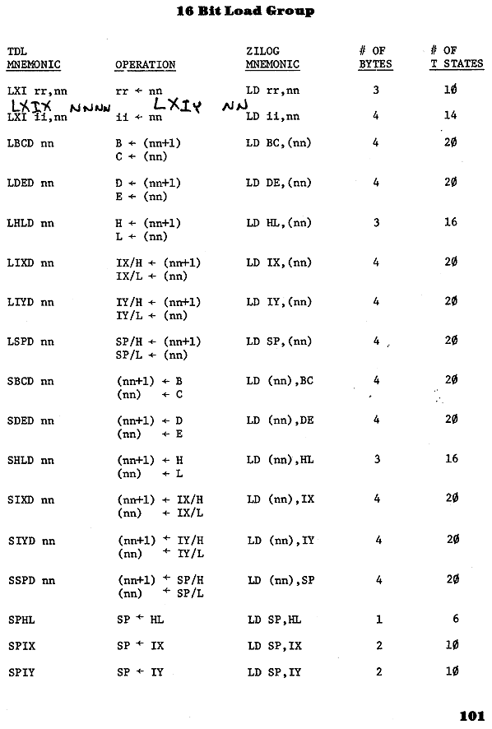

Image of page 102 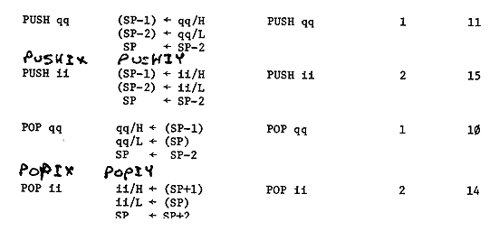

Image of page 103 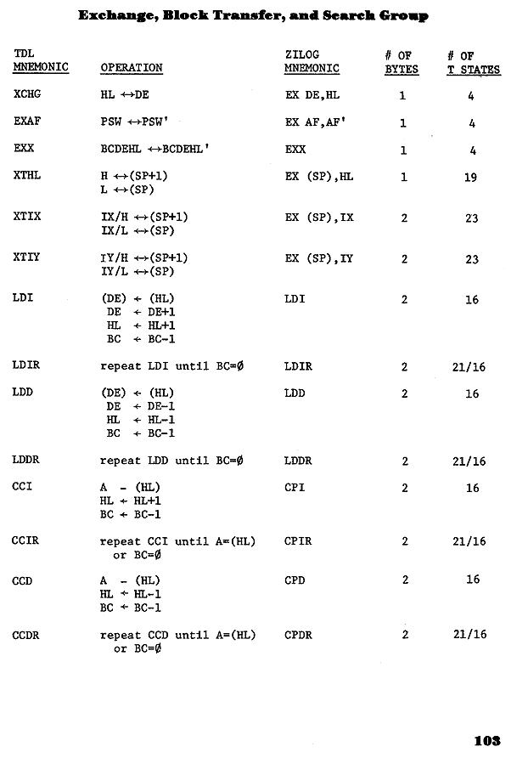

Image of page 104 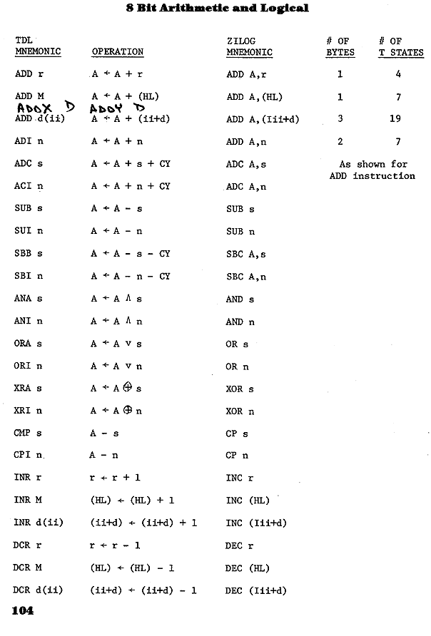

Image of page 105 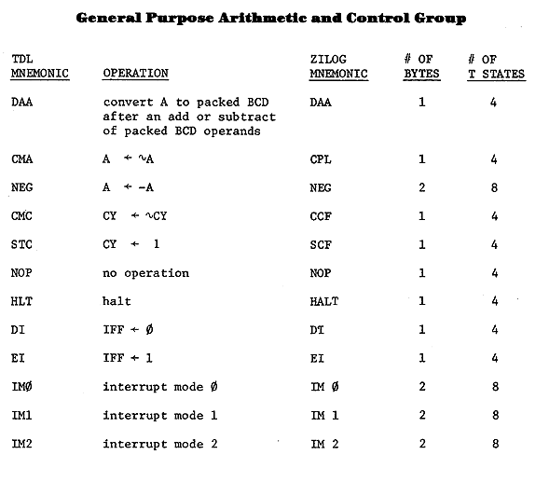

Image of page 106 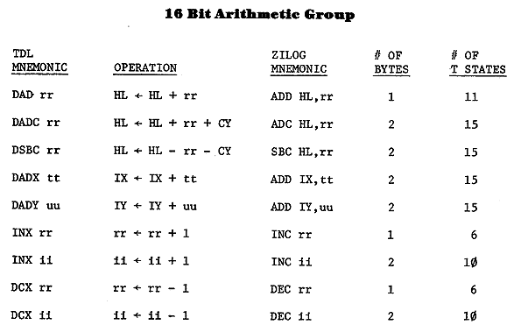

Image of page 107 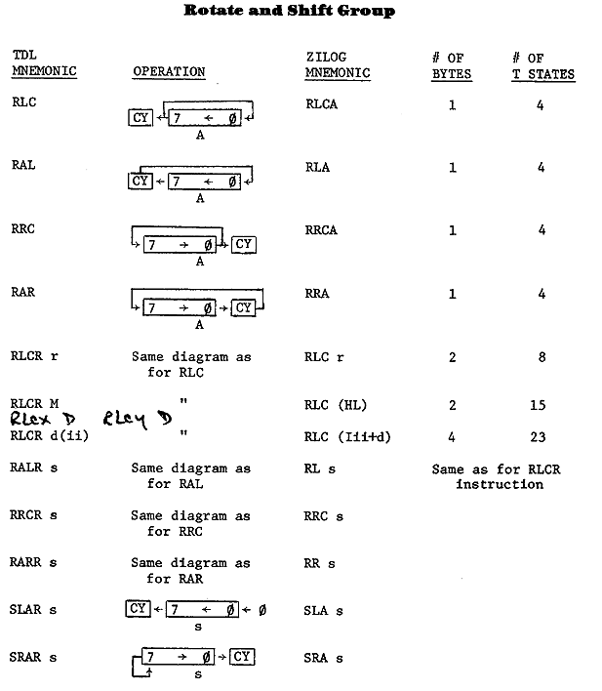

Image of page 108 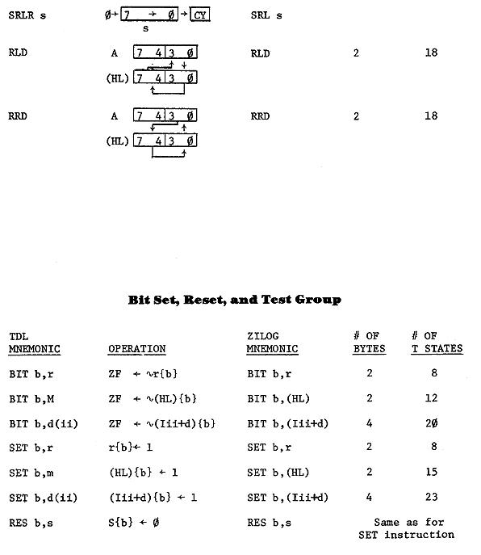

Image of page 109 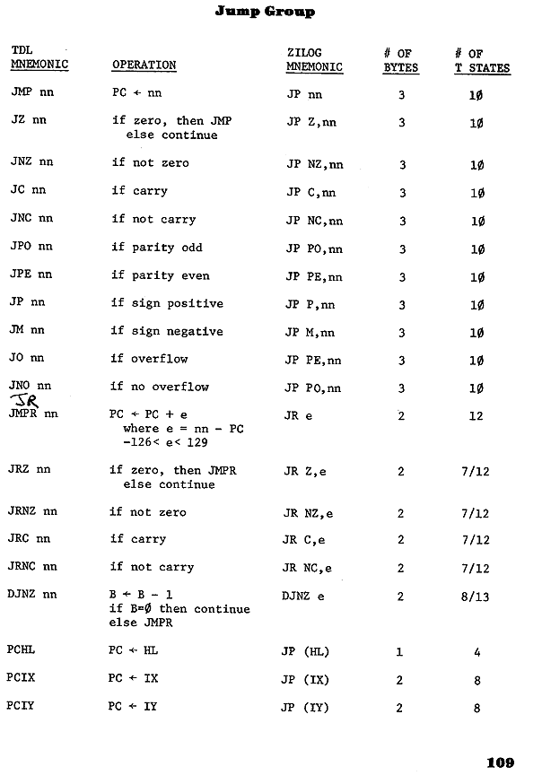

Image of page 110 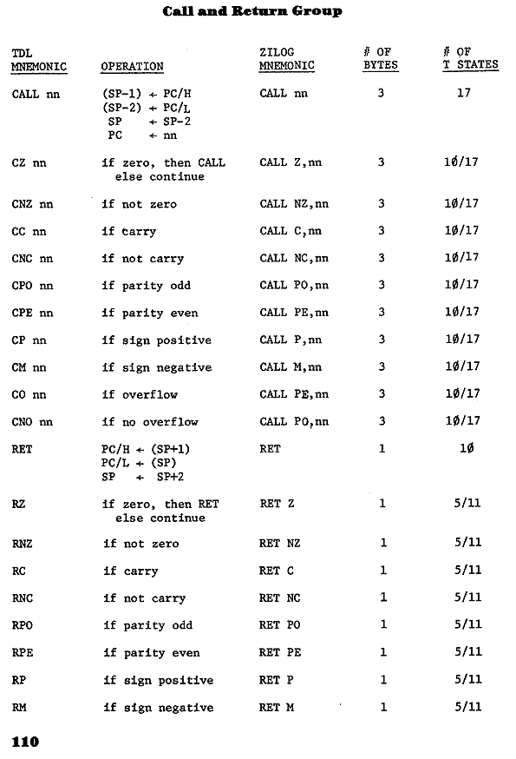

Image of page 111 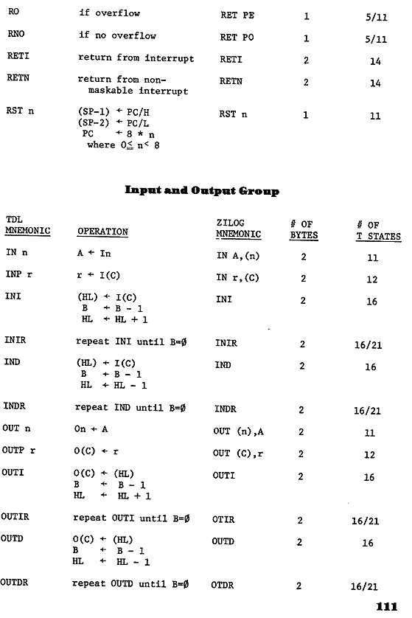

## INDEX TO SUBROUTINES

|  |  |
| --- | --- |
| ADJPTR | [33](http://web.archive.org/web/20021012231845/madscientistroom.org/chm/Sargon.html#P33) |
| ADMOVE | [36](http://web.archive.org/web/20021012231845/madscientistroom.org/chm/Sargon.html#P36) |
| ANALYS | [85](http://web.archive.org/web/20021012231845/madscientistroom.org/chm/Sargon.html#P85) |
| ASCEND | [64](http://web.archive.org/web/20021012231845/madscientistroom.org/chm/Sargon.html#P64) |
| ASNTBI | [80](http://web.archive.org/web/20021012231845/madscientistroom.org/chm/Sargon.html#P80) |
| ATKSAV | [42](http://web.archive.org/web/20021012231845/madscientistroom.org/chm/Sargon.html#P42) |
| ATTACK | [39](http://web.archive.org/web/20021012231845/madscientistroom.org/chm/Sargon.html#P39) |
| BITASN | [76](http://web.archive.org/web/20021012231845/madscientistroom.org/chm/Sargon.html#P76) |
| BLNKER | [94](http://web.archive.org/web/20021012231845/madscientistroom.org/chm/Sargon.html#P94) |
| BOOK | [65](http://web.archive.org/web/20021012231845/madscientistroom.org/chm/Sargon.html#P65) |
| CASTLE | [34](http://web.archive.org/web/20021012231845/madscientistroom.org/chm/Sargon.html#P34) |
| CHARTR | [82](http://web.archive.org/web/20021012231845/madscientistroom.org/chm/Sargon.html#P82) |
| CONVRT | [93](http://web.archive.org/web/20021012231845/madscientistroom.org/chm/Sargon.html#P93) |
| CPTRMV | [73](http://web.archive.org/web/20021012231845/madscientistroom.org/chm/Sargon.html#P73) |
| DIVIDE | [93](http://web.archive.org/web/20021012231845/madscientistroom.org/chm/Sargon.html#P93) |
| DRIVER | [69](http://web.archive.org/web/20021012231845/madscientistroom.org/chm/Sargon.html#P69) |
| DSPBRD | [89](http://web.archive.org/web/20021012231845/madscientistroom.org/chm/Sargon.html#P89) |
| ENPSNT | [32](http://web.archive.org/web/20021012231845/madscientistroom.org/chm/Sargon.html#P32) |
| EVAL | [60](http://web.archive.org/web/20021012231845/madscientistroom.org/chm/Sargon.html#P60) |
| EXECMV | [97](http://web.archive.org/web/20021012231845/madscientistroom.org/chm/Sargon.html#P97) |
| FCDMAT | [75](http://web.archive.org/web/20021012231845/madscientistroom.org/chm/Sargon.html#P75) |
| FNDMOV | [59](http://web.archive.org/web/20021012231845/madscientistroom.org/chm/Sargon.html#P59) |
| GENMOV | [38](http://web.archive.org/web/20021012231845/madscientistroom.org/chm/Sargon.html#P38) |
| INCHK | [38](http://web.archive.org/web/20021012231845/madscientistroom.org/chm/Sargon.html#P38) |
| INITBD | [27](http://web.archive.org/web/20021012231845/madscientistroom.org/chm/Sargon.html#P27) |
| INSPCE | [91](http://web.archive.org/web/20021012231845/madscientistroom.org/chm/Sargon.html#P91) |
| INTERR | [71](http://web.archive.org/web/20021012231845/madscientistroom.org/chm/Sargon.html#P71) |
| LIMIT | [51](http://web.archive.org/web/20021012231845/madscientistroom.org/chm/Sargon.html#P51) |
| MAKEMV | [98](http://web.archive.org/web/20021012231845/madscientistroom.org/chm/Sargon.html#P98) |
| MATED | [84](http://web.archive.org/web/20021012231845/madscientistroom.org/chm/Sargon.html#P84) |
| MLTPLY | [94](http://web.archive.org/web/20021012231845/madscientistroom.org/chm/Sargon.html#P94) |
| MOVE | [54](http://web.archive.org/web/20021012231845/madscientistroom.org/chm/Sargon.html#P54) |
| MPIECE | [30](http://web.archive.org/web/20021012231845/madscientistroom.org/chm/Sargon.html#P30) |
| NEXTAD | [49](http://web.archive.org/web/20021012231845/madscientistroom.org/chm/Sargon.html#P49) |
| PATH | [29](http://web.archive.org/web/20021012231845/madscientistroom.org/chm/Sargon.html#P29) |
| PGIFND | [83](http://web.archive.org/web/20021012231845/madscientistroom.org/chm/Sargon.html#P83) |
| PINFND | [44](http://web.archive.org/web/20021012231845/madscientistroom.org/chm/Sargon.html#P44) |
| PLYRMV | [79](http://web.archive.org/web/20021012231845/madscientistroom.org/chm/Sargon.html#P79) |
| PNCK | [43](http://web.archive.org/web/20021012231845/madscientistroom.org/chm/Sargon.html#P43) |
| POINTS | [49](http://web.archive.org/web/20021012231845/madscientistroom.org/chm/Sargon.html#P49) |
| ROYALT | [88](http://web.archive.org/web/20021012231845/madscientistroom.org/chm/Sargon.html#P88) |
| SORTM | [58](http://web.archive.org/web/20021012231845/madscientistroom.org/chm/Sargon.html#P58) |
| TBCPCL | [78](http://web.archive.org/web/20021012231845/madscientistroom.org/chm/Sargon.html#P78) |
| TBPLCL | [76](http://web.archive.org/web/20021012231845/madscientistroom.org/chm/Sargon.html#P76) |
| TBPLMV | [78](http://web.archive.org/web/20021012231845/madscientistroom.org/chm/Sargon.html#P78) |
| UNMOVE | [56](http://web.archive.org/web/20021012231845/madscientistroom.org/chm/Sargon.html#P56) |
| vVALMOV | [80](http://web.archive.org/web/20021012231845/madscientistroom.org/chm/Sargon.html#P80) |
| XCHNG | [47](http://web.archive.org/web/20021012231845/madscientistroom.org/chm/Sargon.html#P47) |